 | Year 1 Knowledge Organiser
 | Subject: Science, identify and describe the basic structure of trees |  |  | Term: Autumn Term 2021
National Curriculum |  | Vocabulary | Definitions | Research Opportunities
In science we will:  - Identify and name a variety of common deciduous and evergreen trees.  - Identify and describe the basic structure of trees. |  | roots | the part of the plant that grows underground | Research trees in your local area  Can you find an oak, a willow and a beech tree in your local area? You might want to visit the university grounds where there are lots of different varieties of trees.  Which group do they fit into? Are they deciduous trees or evergreen trees?  Things to talk about …  What kind of animals and birds might live in these trees?  What are the seeds of these trees called and what do they look like?  For some further research you could visit Ashclyst or Haldon Forests on the outskirts of Exeter.
 |  | trunk | a tree’s thick stem
 |  | bark | the hard covering around the trunk and branches of a tree
 |  | stem | the stalk of a plant arising above the ground
 |  | deciduous | sheds its leaves once a year
 |  | evergreen | a tree that has green leaves all through the year
Stoke Hill Characteristics |  | 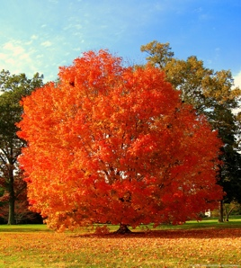  buttercup  blossom |  | Willow Class are also interested in…
Critical thinking  Why is it increasingly important for us to protect our trees?  How is habitat loss having an effect on wildlife?  How can we help wildlife within our school grounds and our local neighbourhood? |  |  |  | How to protect our trees and what we can do in class to reduce waste and recycle.  What can we do to help the local natural environment in order for it to thrive?

