Capacity
Watch the BBC Bitesize clip ‘What is capacity?’ website > Learning at Home > Year 1.
Below there are different amounts of water in a jar. We use different words to describe how much water is in it.
full
nearly full
empty
nearly empty

half full
or
half empty

Draw a line to match the correct description to the jars of sweets. The first one has been done for you.

full
half full
or
half empty
nearly full
nearly empty
empty

Capacity
Draw a line to show how much water is in each container.

half full

full
nearly full
nearly empty

nearly empty
half full

full
nearly full

nearly full
empty
nearly empty
half empty

You could also try filling some containers from your home to the different levels. You do this at the sink, in the bath or even in a paddling pool!
Capacity
Look at the Power Point Capacity website > Learning at Home > Year 1. Investigate how much water different containers can hold and fill in the table on the back of this page.
- Draw the container you have chosen in the first column.
- Estimate how many cups of water it will take to fill the container.
- Use water and a cup to measure the actual capacity of the container. Make sure you fill the cup to the top each time and pour the water in carefully.
- Compare the different containers. Which holds the most water? Which holds the least?

Here are some ideas to help you choose containers:
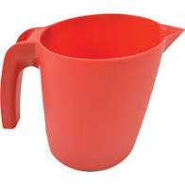
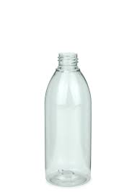
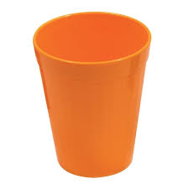

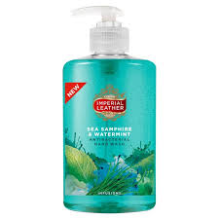
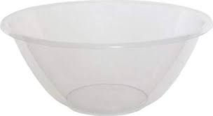

Capacity
Table to show the capacity of different containers
container | estimate of capacity in cups | actual capacity in cups
 | 7 | 9

