Gratitude

Gratitude is feeling thankful and appreciating what we already have in our lives. You don’t have to just be grateful for the big things, gratitude is about noticing the little things too.
We often take things for granted (always expecting them to be there without thinking about it), things like having somewhere to live, having clean water, food, friends, family, and even WiFi!
It is good to stop sometimes and think about these things. By focusing on these positive things in our lives, it can make us feel good, happy and makes us realise how lucky we are. We may not have everything we want (the latest computer game, the best phone, going on holidays every year) but we need to focus on what we do have and what is positive in our lives.
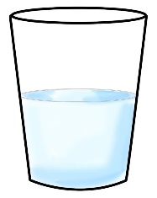
Below are three gratitude activities for you to try out! As well as the activities you can start or end every day by naming three things you are grateful for in your life. It’s a great way to start the day with a positive approach OR an amazing way to end the day feeling happy.

My Gratitude Flower
On each of the petals write things that you are grateful for in your life. Remember they don’t have to be big things, it can be little simple things. Colour in the flower and put it up somewhere at home to remind you of the positive things in your life.
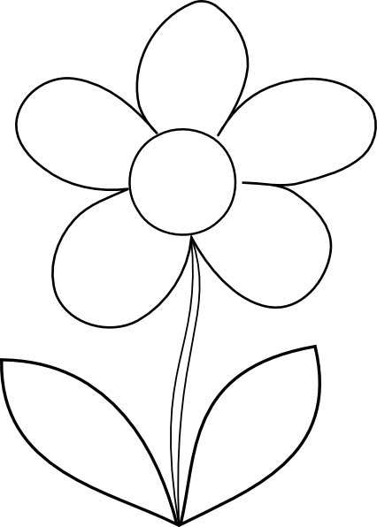

Weekly Gratitude
Each day draw or write at least one thing that you are grateful for. Try and make it something different every day. At the end of the week, look back on each day and remind yourself of all positives of that week.
Monday

Saturday

Thursday

Friday

Wednesday

Tuesday

Sunday

Gratitude Drawing

Below you’ll find 10 simple drawing tasks to help you remember the good things we have in our lives!
- Draw something that makes you happy.

- Draw your favourite place to play or relax.

- Draw someone who helps you.

- Draw something that makes you smile.

- Draw something you love to do.

- Draw your favourite food.

- Draw someone you love.

- Draw your favourite thing to do at home.

- Draw something that makes you feel good.

- Draw something that makes you laugh.

