The Foundation Stage Learning Letter

This term’s projects
We are very pleased that the children have settled well into school life. Each day they are getting to know the rules and routines of our school and increasingly they are becoming independent and powerful learners.
We are supporting the children to make friendships and to develop the vital social skills to be happy and successful in school, and in life.

Having time to play and explore is essential to the children’s wellbeing so that they can feel secure in their environment and further their learning and development. A large part of our day is ‘Explore and Learn’ whish allows the children to follow their fascinations alongside adults.
All of the adults in the Foundation Stage are spending quality time getting to know the children, finding out about their interests and listening to their ideas and thoughts.

To begin this term, our learning will be inspired by the our class names. We will then be led by the children’s interests to see where our learning takes us next!

How you can help

At home:
Help your child to practise writing their name. Make sure they are using a tripod pencil grip and forming their letters correctly.

Watch ‘The Gappy Smile’ together on ‘Get Well Soon’ with Dr Ranj and Nurse Morag.

Visit:
Stoke Woods or Haldon Forest and enjoy the outdoors and fresh air. Maybe you could look for an interesting
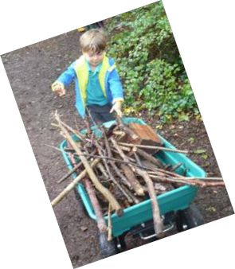Mathematics
Have you got the counting bug? Our mathematics at this time of the year is all about numbers. Accurate 1:1 counting is a vital skill to learn and it is so easy to practise. Take every opportunity to count groups of objects such as apples in a bag, pennies, conkers, leaves and acorns. Why not count the stairs to bed or the cars on the street?
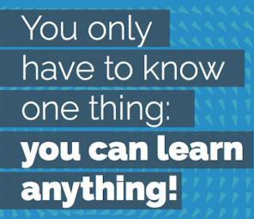Look out for numbers in the environment such as prices at the supermarket, house numbers, registration plates and road signs. You’ll be surprised how many numbers you’ll be able to spot!
Literacy
Children have begun to develop their phonic skills through daily Letters and Sounds inputs. It is important that they establish firm foundations in Phase 2 of our program before they begin to bring Guided Reading books home to share with you.
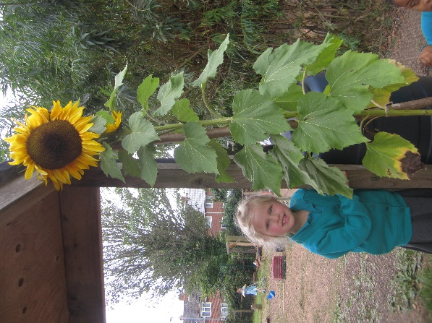
Don’t forget to share a bedtime story every evening. By reading to your child regularly you are helping them to foster a love of reading, develop their vocabulary and listening skills and encouraging their imagination and understanding.
Many of the children are becoming interested in the early stages of writing. Please give them plenty of opportunities to draw, paint and write at home.

Foundation Stage Learning Letter – Autumn 2021
stick to play with. https://www.woodlandtrust
.org.uk/visiting-woods/find- woods/

Look out for:
Seasonal changes around us. Notice the autumnal leaves and search for conkers or acorns.
‘Play is often talked about as if it were a relief from serious learning. But for children play is serious learning. Play is really the work of childhood.’ Fred Rogers

Tripod Grip use the thumb and first two fingers, pencil leaning back a little - for left handers this is the same.

Inspire

~ Discover
~ Succeed

Creating independent learners
We encourage the children to feel proud when they can achieve things by themselves. This includes taking responsibility for their possessions. We are establishing routines whereby children are able to ensure snack pots, water bottles and book bags find their place in the classroom.
Grown ups can help by encouraging children to put on their clothes, coats and shoes by themselves and by helping them to eat independently at meal times.

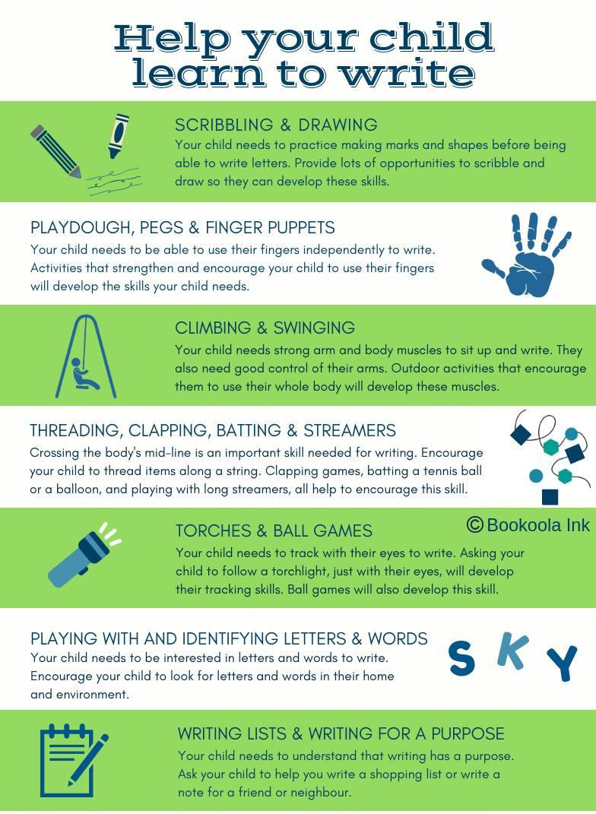

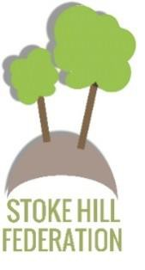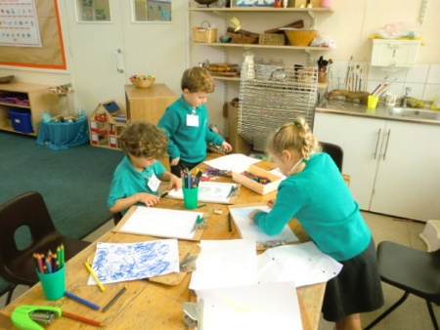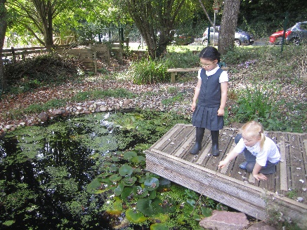

Foundation Stage Learning Letter – Autumn 2021

