

**Knowledge Organiser ~ Foundation Stage**

***‘In the dark, dark night’***

**Area of Learning**: Knowledge and Understanding of the World

**Term:** Autumn 2 2021

**Things to do at home**

Look out of your window at night…what can you see?

Research your favourite nocturnal animal on the internet.

Set up a night time camera in your garden to see what kind of wildlife comes to visit!

Make a dark den in your house and play with different lights. Can you make some shadows?

Go on a night walk and paint a night time picture.

**Key Questions:**

How does a torch work?

What do you and your family celebrate?

What can you hear at night time?

Which nocturnal animals might you see near your house at night?

Why are some people scared of the dark?

How can we help nocturnal animals like hedgehogs?

How are shadows made?

Why is it dark at night?

What questions do you have about the dark, dark night?

**Key Vocabulary:**

|  |  |
| --- | --- |
| Word | Definition |
| celebration | to do something special or enjoyable for an important event, holiday or occasion |
| telescope | something that makes far-away objects look closer |
| nocturnal | active at night |
| shadow | darkness in a place caused by something stopping light shining through |
| dark | with little or no light |
| swishing | to move quickly through the air |

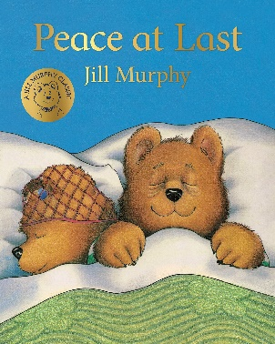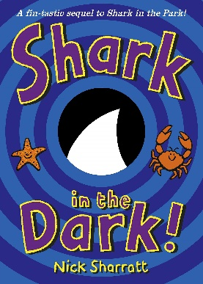v

**Share a book with your child.** Here are a few ideas…

*Owl Babies*

*Peace at Last*

*Shark in the Dark*

*Look up!*

*The Night Box*