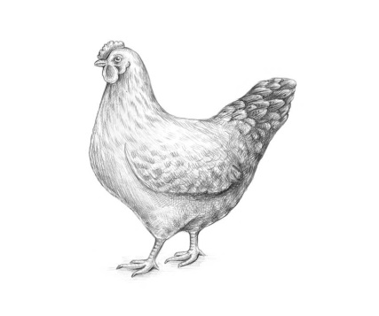
Name:
W.B. 19.10.20
Science WALT draw a life cycle of a chicken
Label and explain what is happening in each part or the life cycle. Use arrows and numbers to help explain the life cycle.

