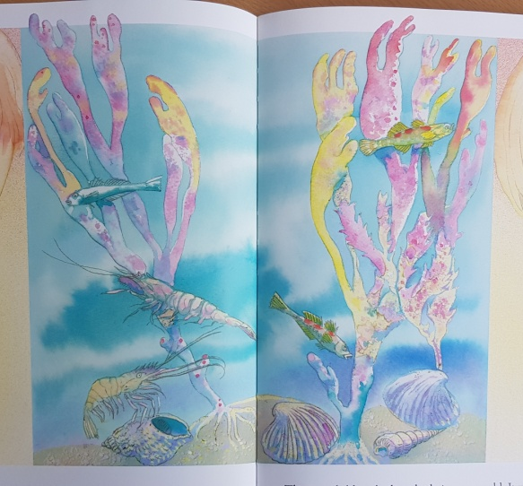
One World
Watch the story One World and the information clip clip What’s in a rockpool? website>Learning at Home>Year1.
Create your own rock pool world in the bucket below. Use beautiful colours like the illustrations in the book and include the creatures and plants you might find in a rockpool.
