**Knowledge Organiser ~ Nursery**

**Learning how to use natural materials in the Studio and in our storytelling.**

**Areas of Learning**: Expressive Arts and Design

**Term**: Autumn 2 2021

**Stoke Hill Characteristics - children as experts**

The children are learning how to print and dye fabric using natural materials such as avocado and blackberries, guided by Laura-Jane, who leads the creative projects in the Nursery. The children also learnt how to create a Batik print, using glue instead of hot wax!

**Key Vocabulary – learning new words and their definitions**

|  |  |
| --- | --- |
| Word | Definition |
| **batik** | A method of dyeing and printing patterns on fabric using hot wax. |
| **Studio** | The working place of a painter, sculptor or photographer. |
| **setting** | The time and place of a story. |
| **character** | A person, animal or creature in a story. |
| **dilemma** | A difficult situation or problem. |
| **plot** | The sequence of events that make up a story. |
| **twist** | An unexpected development in the story. |

**Cultivating the children's curiosity – designing and creating our own books**

The children in the Nursery have a real interest in story telling and performing. They will have the opportunity to design and create their own characters, books and story boxes as well as telling stories in a pop-up theatre.

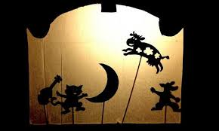

**Sharing knowledge**

Why not make your own book at home. You could use an elastic band for the spine or you could make a zig-zag book.

I wonder who the main character will be…..

**Spend some time reading your favourite stories at home**

Talk about the characters, the setting and the plot. Maybe think about how the ending could be changed.

