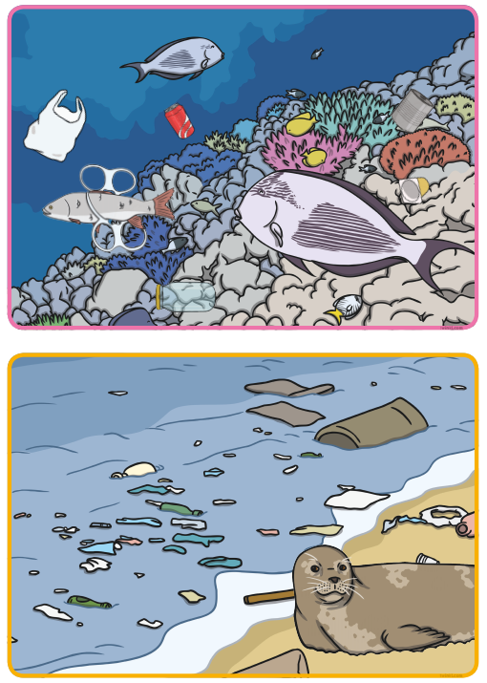
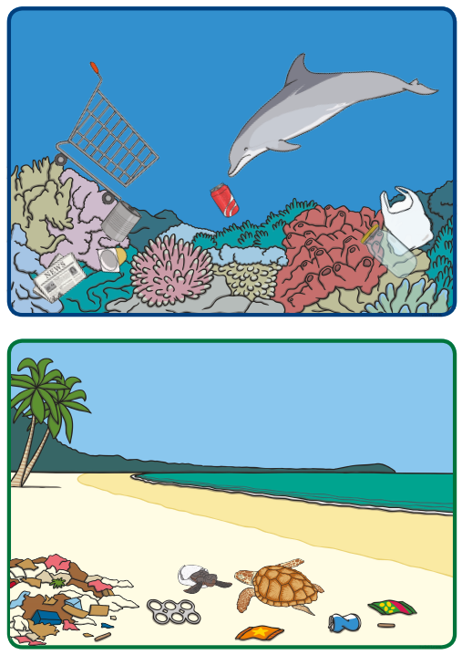
Looking after our Oceans Look at the PowerPoint All about plastic pollution website>Learning at Home>Year 1. Then look at these 4 pictures. What can you see? What is happening in the pictures? Why has this happened? What do you think about this? Discuss what you see and think with your grown up. How could we change what is happening in these pictures?

Choose one picture and write some sentences to explain what is happening and what you think we should do to try and change this.

_____________________________________________________________________________________
Word bank sea ocean pollution rubbish waste creatures poison plastic destroy habitat coral contaminate dangerous

