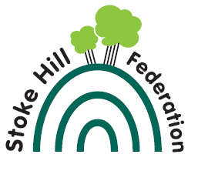
Year 6 Spelling - Summer Term

This term’s spellings focus on different areas of the curriculum that we will be looking at between now and the end of the year. See if you can guess the theme each week.

April 21st - Art | April 28th - Computing | May 5th - DT | May 19th - Geography | June 9th - Geography
Organic | Procedure | Seasonality | Compass | Tropic of Cancer
Curvaceous | Hex file | Source | Scale | Tropic of Capricorn
Proportion | Code | Utensil | Symbol | Arctic circle
Intricate | Micro:bit | Design | Grid Reference | Antarctic circle
Tessellation | Syntax | Tare | Latitude | Prime Meridian
Harmonious | Software | Weigh | Longitude | Europe
Hue | Input | Measure | Equator | Asia
Graduated | Output | Hygiene | Northern Hemisphere | Africa
Mid tone | Variable | Seasoning | Southern Hemisphere | Australia
Diffused | Algorithm | Knife | Greenwich | America

June 16th - History | June 23rd - Music | June 30th - PE | July 7th - Science
Mayan | Composer | Positions | Translucent
Tributes | Notation | Feint Pass | Transparent
Slaves | Crotchet | Offside | Opaque
Trade network | Minim | Fault | Artificial
Obsidian | Rest | Half-volley | Natural
Luxury | Quaver | Rally | Current
Hierarchy | Semibreve | Acrobatic | Voltage
Ceremonial | Time signature | Dismount | Adaptation
Prestige | Accidentals | Somersault | Evolution
Elites | Duration | Vault | Offspring

