Stoke Hill Junior School

Update 22.1.21

Federation News – Governor Update
In light of the fact that both headteachers will be leaving at the end of this school year, we wanted to let parents and carers know how the governing board is approaching the task of finding their replacements.

It is evident to us that most parents, carers and staff are keen to preserve the ethos and values of the Federation, which have been instilled over a long period of time by Roy Souter and Sarah Mackay. This is a priority for the governing board as we strongly feel that the Stoke Hill Federation is a special and in many ways unique school.

We are in the process of consulting as to the best way forward. Our current intention is to complete our consultation within the next couple of weeks and for an advert to go out before the February half-term. Our hope is that we will complete the recruitment process by the end of the Easter term.

We will keep you updated in due course.

Tom Urwin and Amy Bickford, Co-Chairs of Governors

Testing
From next week all members of staff across both schools will be offered the chance to take self-administered twice weekly Covid tests. The idea is that this will allow us to pick up asymptomatic cases, and break the chains of transmission within the community.

This does mean, however, that there is more likelihood that we will find positive cases amongst our staff which could lead to more groups of children having to self-isolate for a time. We will continue to provide online learning if this is the case, although this may have to be in a different format if a teacher becomes unwell.

Online learning - Reading
Here are some ways you can access free eBooks easily so you can carry on reading and taking AR quizzes all the time you are at home:

You can use the library app, Libby. On Libby you can access lots and lots of eBooks that are owned by Devon Library Services. You can read on your phone, your tablet or your computer by either installing an app or by using the online version of the software. There are even some audio books so you can have someone else do the story reading for you while you lie back and listen.

Using Libby
If you have a library ticket you are ready to go. You can ask your grown up to install the app on the device you want to use for reading and enter your library information: https://www.overdrive.com/

Or you can use the library app online in your browser: https://libbyapp.com/welcome

If you DON’T yet have a Devon Library ticket, you can sign up online for a temporary borrower number and then you will be ready to use Libby too! To sign up for a library ticket ask your grown up to follow this link and fill out the online form: https://www.devonlibraries.org.uk/web/arena/join-thelibrary Then you can add the library app to your device as well.

You can also use Oak Academy resources. Each week there will be a new book and interview with an author on the Oak Academy website in their Virtual Library https://library.thenational.academy/. The first one is an interview with Jacqueline Wilson and you can read her book ‘Tracy Beaker’ on the website.

Chromebooks
We are lucky to have had the resources to be able to lend over 70 Chromebooks to children to help children who are working at home. This week we received an allocation of 21 more Chromebooks from the DfE. We have already loaned some of these to children, but we still have a few available. If your child is struggling to complete their home learning because they don’t have access to their own device please let us know and we can arrange for you to come and collect one.

Enter the quiz and you could be the winner of this week’s MYSTERY PRIZE!

- What is the name of the new President of the USA?
- What is the name of the new Vice-President of the USA?
- What is the 14th letter of the alphabet?
- What is the capital city of France?
- Which rugby union team are currently English and European champions?
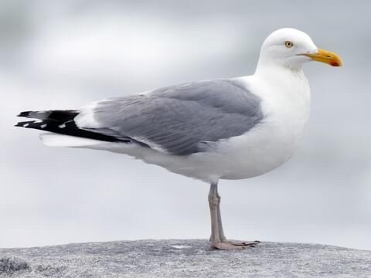
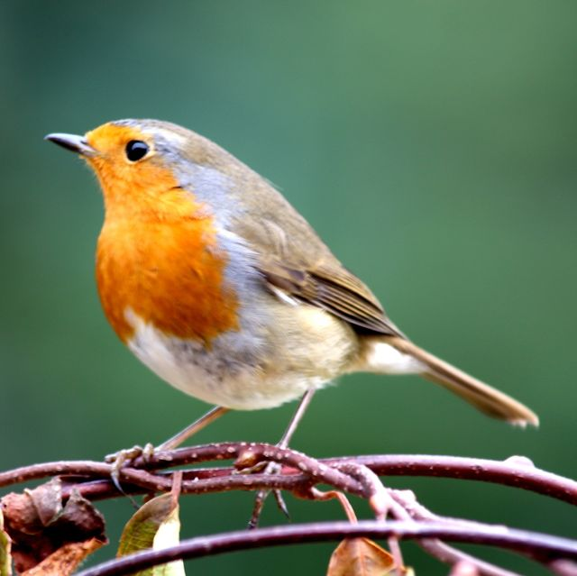
- Name these birds:
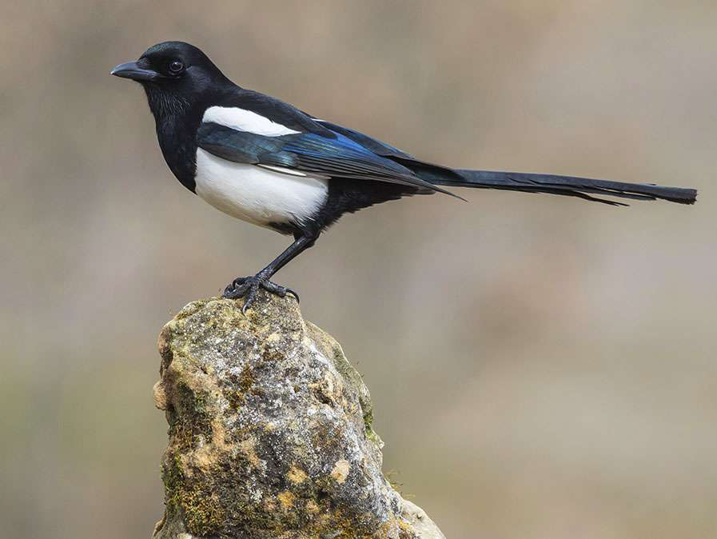
- Which celebrity won the latest series of Strictly?
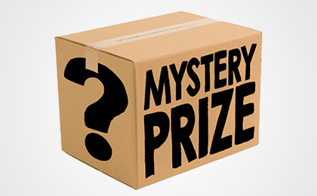
- How many strings are there on a violin?
- Which county do you live in?
- What day of the week will Christmas Day fall on this year?

Please send your entries to quiz@stokehill.devon.sch.uk by next Thursday.

Will we choose a winner at random, and they will win the mystery prize!

Have a good weekend ~ Roy Souter

