 | Year 2 Knowledge Organiser
 | Subject: Science, animals including humans |  |  | Term: Autumn term 2021
National Curriculum |  | Vocabulary | Definitions | Research Opportunities
In science we will..  - Notice that animals, including humans have offspring which grow into adults.  - Find out about the basic needs of animals for survival (water, food and air).  - Identify that most living things live in habitats to which they are suited and describe how different habitats provide for the basic needs of different kinds of animals and plants, and how they depend on each other. |  | habitat | the natural home or environment of an animal or plant | Go on a nature hunt!  Go on an animal/bug hunt in your garden or in a local park like Mincinglake Valley Park.  How many different insects, birds and animals can you spot?  Try and draw as many different ones as you can.  What do you notice? How do they move? You could try and sort them into creatures that  crawl, fly, wriggle, run, or hop.  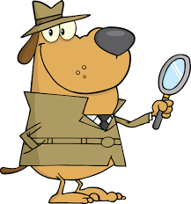  Why do you think they live where they do? Do they live on the ground, under the ground, or in a tree?  Choose one creature to find out 5 fascinating facts about!
 |  | offspring | an animal’s young
 |  | adult | an animal that is fully grown
 |  | survival | staying alive and safe
 |  | life cycle | the journey of a living thing from beginning to end
 |  | condition | the state of something or somewhere, what it’s like there
Stoke Hill Characteristics |  | 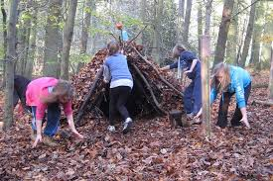  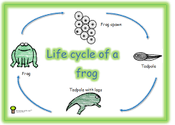  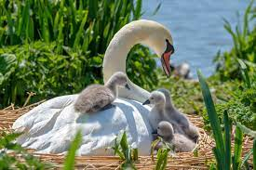  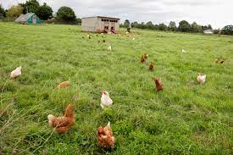  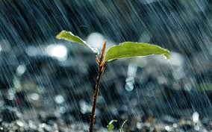  soi  buttercup  blossom |  | Year 2 are also interested in…
Critical thinking  How many animals or insects can you name?  How do they move?  Where do they live?  What do they eat?  What do they look like when they are babies?  Why do different animals and insects live in different places? |  |  |  | Chickens!  What kind of habitat do chickens like?  What do chickens need to survive? How do chickens change from when they are born to when they are fully grown?  Which came first…the chicken or the egg?

