A parent’s guide to help you manage your child’s internet use and screen time

These days we give our children access to a variety of different screen-based devices, from smartphones and tablets through to laptops. This is a Stoke Hill parent’s guide to the technical solutions that are available to help you regulate your child’s access time (both duration and the time of day), should you wish to do so. It also gives tips on how to prevent your child from accidentally accessing inappropriate content.
Here are some tips for securing common devices:
SMARTPHONES AND TABLETS
Apple iPhone and iPad
For my child’s iPhone (and our family iPad) I have used a ‘parental controls’ app. There are many available, and I have experience of using:
- MMGuardian - http://www.mmguardian.com/
- Kidslox - https://kidslox.com/en/
I have found Kidslox easier to use than MMGuardian. The key feature of both is that you can restrict your child’s access to certain apps to within particular periods of the day (e.g. between 8am and 8pm only). However, it appears to be a limitation imposed by Apple that these time boundaries can only be placed on ‘installed’ apps such as WhatsApp, Instagram and Facebook etc. Note that you can control their access to the apps rated for certain age ranges (e.g. 4+, 9+, 12+ etc.)
However, your child will still have unlimited access to the ‘built-in’ apps, which include Phone, Messages, Music and FaceTime.
Access to the web can also be controlled via the built-in Safari browser (Kidslox) or via a specially secured browser (MMGuardian). In either case, you have control over how long your child has access to these.
At this time only Kidslox (out of the two above) supports restricting access to apps for specified time limits (number of hours or minutes) per day. However, this functionality is far from perfect and requires the app to be started and running constantly on the phone. If the child closes the app then the time limits stop working, and you have to grab the phone and open the app again!

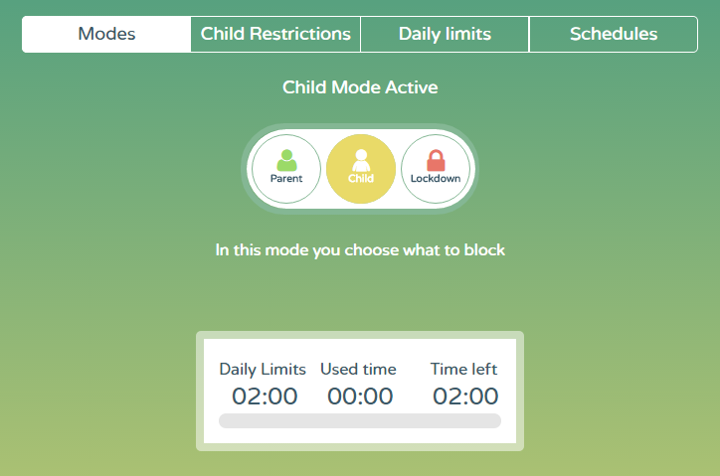

Above is shown an image from the portal website for my own account with Kidslox. The app that I can install on my phone looks very similar and has the same features.
With either of these you can
- Switch modes: Switch between ‘Parent mode’ (enter a PIN and get full access to the child’s phone), ‘Child mode’ (your child has access to all of the apps for the predefined hours of day, with the accessible content restricted on the browser) and ‘Lockdown mode’ where they only have access to the ‘built-in’ apps.
- Set Child Restrictions: Set the types of content your child can access in the browser, allow or disallow them access to the camera and/or app store etc.
- Set Daily time limits: Set a maximum number of hours and minutes that your child has access to ‘Child mode’ before the phone goes into ‘Lockdown’.
Please see the Kidslox website for more details.

Google Android
The above two apps can also be used on Android. The good news is that they are more fully-featured on this platform; it is possible to more finely control access to individual apps. Separate schedules (with time durations) can be setup for each individual app! Android seems to be a bit more friendly to parents than iOS!

Therefore, at present, an Android phone or tablet may be the better choice (over Apple iOS) for parental controls.

PCs (LAPTOPS AND DESKTOPS)

Microsoft Windows 10
The general approach is the same across each of these versions of Windows: create a separate login account on your computer for your children. You then configure various parental control features against this account in order to limit your child’s screen-time and access to inappropriate web content.
With Windows 10, most of the configuration is done within the account.microsoft.com/family website. Please see the guide below:
https://support.microsoft.com/en-us/help/10551/microsoft-account-set-up-family-after-upgrade

When you create a separate login account for your children make sure the account is just a ‘standard user’ and not an ‘administrator’. This will further protect your computer from inadvertently having malware installed on it!

Microsoft Windows 8 and 8.1
Windows 8 (and 8.1) come with parental controls that offer similar features to that in Windows 10. However, instead of doing the configuration online you actually do it in the Control Penal.
Again, you can restrict your child’s access to certain times of day and also for a certain number of hours or minutes per day. You can also setup ‘web filtering’ to disallow inadvertent access to inappropriate material via with web browser.
https://support.microsoft.com/en-us/help/2782156/windows-8-set-up-family-safety-microsoft-account

Microsoft Windows 7
Windows 7 comes with a built-in facility called ‘Family Safety’. You can access it from the Control Panel. It is not quite as sophisticated as the facility in Windows 8 and 10. For example, it only allows access to be allowed or denied for certain times of day (does not allow a maximum number of minutes or hours to be imposed).
Here is a guide on how to use this facility:
http://www.howtogeek.com/howto/10524/how-to-use-parental-controls-in-windows-7/

Apple Mac OSX
The full gamut of parental controls seems to be available for this platform (although I haven’t had the opportunity to test it). Please see the link below for more information:
https://support.apple.com/kb/ph18571?locale=en_GB

Key controls are:
- Apps: Specify which apps the child can access. If you allow the child to access the App Store, you can specify a permitted app rating so the child only sees age-appropriate apps. You can also set up a simplified Finder for an inexperienced user.
- Web: Limit access to websites, or allow unrestricted access.
- People: Restrict a child’s contact with other people through ‘Game Center’, Mail, and Messages.
- Time Limits: Set time limits for weekdays, weekends, and bedtime.
- Other: Hide profanity in the dictionary and other sources, and block using the built-in camera, Dictation, burning CDs and DVDs, or changing the password or printer settings.

GAMES CONSOLES

Microsoft Xbox
For the ‘Xbox 360’ you manage parental controls on the games console itself – see the guide below:
http://support.xbox.com/en-GB/xbox-360/security/xbox-live-parental-control
On the newer console ‘Xbox One’ you also have the option of managing them online – see
https://privacy.microsoft.com/en-GB/xbox-one-privacy-and-online-safety

With these options, you can control
- Which games can be played.
- Which films and TV shows can be watched.
- How long each family member can use the console on a daily or weekly basis.
- Whether or not a family member can access Xbox Live.

Sony PlayStation 4
Similar controls for the PS4 can be found at the link below:
http://manuals.playstation.net/document/gb/ps4/settings/restrict.html

SOME GENERAL POINTS

A note on YouTube:
I strongly recommend setting ‘restricted mode’ to ‘on’ to prevent your child from inadvertently accessing inappropriate material. When accessed from the normal web browser, it is possible to add a password lock to prevent them from sneakily switching the setting off. However, it seems to me that the YouTube app on the iPad does not have this password feature – so your child can just go and switch the setting off!

A point about FaceBook privacy settings:
Up until sometime in 2014, the default privacy settings for a new user were ‘open to the public’. This applied to profile, timeline, everything. After that point, they changed it to ‘friends only’. Subsequently, many people’s older postings are completely visible to the public.
You may like to check your own page using the ‘View As’ option detailed against the link below:
https://www.facebook.com/about/basics/what-others-see-about-you/profile

Installing effective internet security on your PC will go a long way to protecting it. I find some of the commonly available packages (such as Norton and McAfee) a little too intrusive on my Windows PC and tend to prefer eSet – see http://www.eset.co.uk

In my experience e-book readers like the Kindle (not the Kindle Fire), which have an e-ink, rather than an LCD-based screen seem to be less likely to cause sleeplessness when used before bedtime.

If you have any questions, please email AndrewPageAdvice@gmail.com and I will try to get back to you.

