Stoke Hill Junior School

Update 29.1.21

Keeping Safe
Please can you help keep all of our children, staff and families as safe as possible by following the government’s rules about social mixing during the current national lockdown. The guidance is very clear: ‘You must stay at home. This is the single most important action we can all take to protect the NHS and save lives. You must not leave your home unless necessary’.

- You cannot leave your home to meet socially with anyone you do not live with or are not in a support bubble with (if you are legally permitted to form one).
- You may exercise on your own, with one other person, or with your household or support bubble. This should be limited to once per day, and you should not travel outside your local area.
- You cannot meet other people you do not live with, or have not formed a support bubble with, unless for a permitted reason.
- Stay 2 metres apart from anyone not in your household or support bubble.
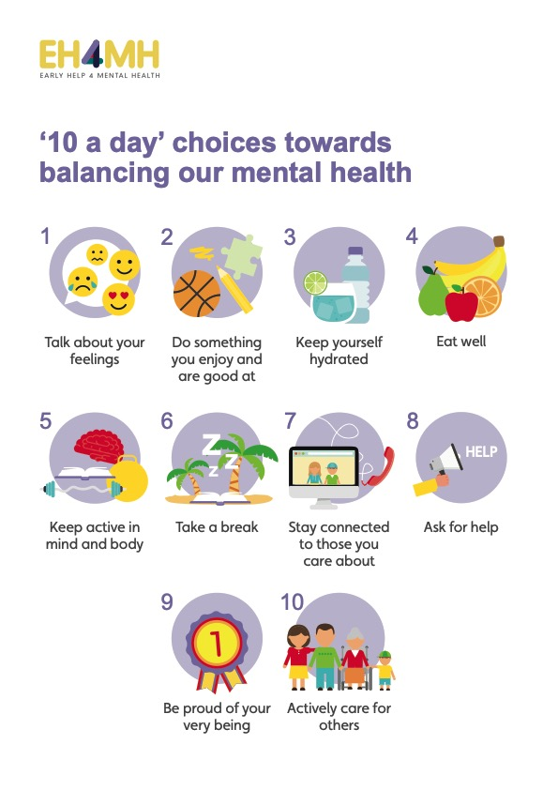
Online learning
We teach the children the importance of looking after their mental health. One way they can do this is to have a go at making the ’10 a day’ choices identified by Early Help for Mental Health.

Given the extraordinary circumstances we are living through, this is more important than ever.

We are so proud of the children (and grateful to you) for the way in which they have embraced learning from home. The levels of effort and engagement are amazing, and will help the children enormously when we are all back in school. Having a go at the ’10 a Day’ will help balance the children’s day – please have a look with them and see what you can manage together.

Teachers’ Planning
For each year group, there will be one day in the next two weeks where online learning will be different to normal. There will only be one Google Meet (first thing in the morning to remind the children what they need to do for the day) and the activities planned will involve less screen time than usual. This is to allow us to release teachers from their classes to plan learning for the coming half term. The days vary for each year group, but we will let you know in advance so that you know what to expect.

Quiz
Last week’s quiz was meant to be a one-off, but we had so many entries I thought we’d do another one today.

The answers to last week’s questions were:
- The name of the new President of the USA is Joe Biden
- The name of the new Vice-President is Kamala Harris
- The 14th letter of the alphabet is N
- The capital city of France is Paris
- Exeter Chiefs are the English and European rugby union champions
- The birds were a herring gull, robin and magpie
- Bill Bailey won the 2020 Strictly series
- There are 4 strings on a violin
- We live in Devon
- Christmas Day will be on a Saturday this year

We put all the correct entries into a hat and drew out the winner, and it was… Ian in 3G! Well done Ian – your Mystery Prize of a ‘Super Mega Art Set’ will arrive at your house in the next few days.

This week’s questions:
- Who is the current British Prime Minister?
- Who is the current British Chancellor of the Exchequer?
- What is the 19th letter of the alphabet?
- What is the capital city of New Zealand?
- Who is Exeter City’s manager?
- How many strings are there on a guitar?
- Which counties share a land border with Devon?
- How many days will there be in 2021?
- Which duo present ‘I’m a Celebrity, Get Me Out of Here’?
- Name these flowers:
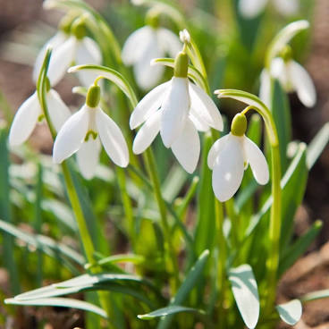

Please send your entries to quiz@stokehill.devon.sch.uk by next Thursday.

Again, we will choose a winner at random, and they will win another mystery prize!

Have a good weekend ~ Roy Souter

