Dealing with Anger

We have all felt anger at some point in our lives. It is a very common emotion to feel and it is perfectly normal to feel anger in certain situations.
You may have found yourself getting angry a bit more since the schools have been closed, again this is very common. We have been spending a lot more time than usual at home and with our family members. We can often annoy each other when we spend lots of time together, especially when there is no where else to go to get away from the situation.

Here are some things that might make you angry (especially at the moment):

- My brother or sister annoying me.

- My parents telling me off

- Being hungry

- Being tired

- Being worried about things that are happening.

- When people don’t listen to me.

- Not being able to be with my friends.

What are your anger warning signs?
Whenever you start to get angry your body sends you warning signs. It is important to pay attention to these warning signs so that you know when to start using a calming down skills.
Colour in the warning signs that happen to you (and remember everyone is different) and add any others that you have in the empty thought bubbles.

My face becomes hot and red
My hands become fists
I hit out

I want to cry

I shout

My chest feels tight
My heart beats really fast
I get sweaty
I breathe quickly

My body starts to shake
I get tummy ache

Ways to calm down

Everyone has different techniques they use to calm down. The way that works for you may not work for someone else. When your body gives you the warning signs that you are getting angry try to give one of these a try and see which works better for you!

- Blowing out the candles: Have your fingers and thumbs up in front of you, these are your candles. Take a deep breath in through your nose and then slowly blow out towards one of your fingers (or candles) and put that finger down. Take another breath in and do the same with the next finger/candle. Carry on with your deep breathes in and your slow blowing out until all your fingers and thumbs are down. This should help slow down your breathing and calm you down.
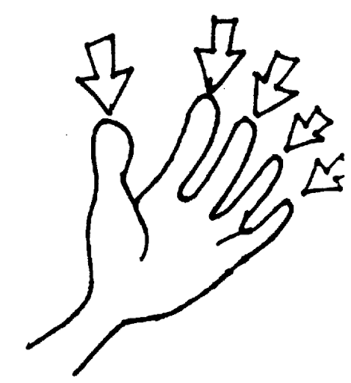

- Squeeze and stretch: Interlace your fingers and squeeze gently together (not too hard) and hold for 5 seconds. Then put your arms straight out in front of you, palms facing out, fingers still interlaced for another 5 seconds. Then stretch your arms and hands up high, going onto your tip toes if you want. Release your arms down slowly to your side making a rainbow shape.
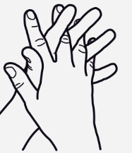
This helps to release the tension in your arms when you are angry and reduces that urge to hit out.

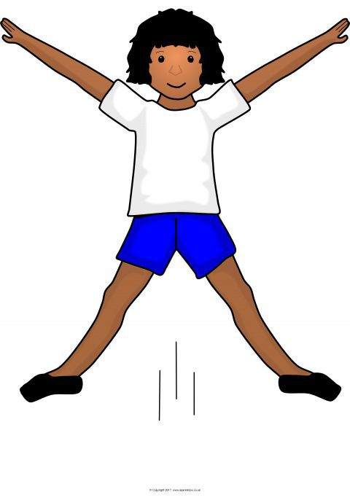
- Exercise: Do some star jumps, kick a football against the wall outside, run around the garden or on the spot, go on a trampoline, take a walk, punch a pillow, skipping, whatever exercise you can find that helps. It can help you let off so steam and gives your body a chance to focus on something else.

- Write it down: Write down why you are angry then scribble all over it, tear it up, and put it out for recycling! OR write down why you are angry and when you are calm come back to it and see how you feel about it then.
This Photo by Unknown Author is licensed under CC BY-SA

- Listen to music: Get your favourite song, put on your headphones and listen. Dance like nobody is watching and let some steam out. Focus on the song and the lyrics and this will distract you from what was making you angry.

Below have a go at making your own Calm Wheel!
In the different sections of the wheel write ways that you know help you calm down. Fill it up as time goes on and then you will have a choice of ways to let off steam and help you relax. Make it bright and colourful and keep it somewhere handy so you can grab it when you are angry.
My Calm Wheel

