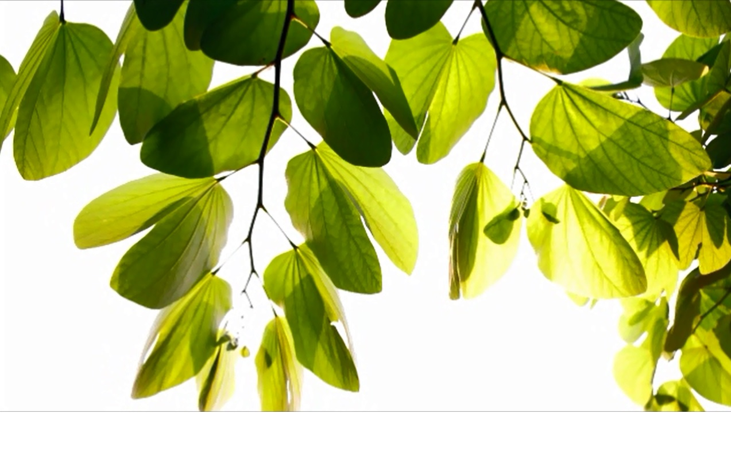

Year 1 Learning Letter

This Half Term’s Project

Gr

**Year 1**

**Autumn Home Learning**

**ESSENTIAL each week:**

**Reading**

x3 sessions of up to 10-15 minutes reading the Guided Reading book. Please share your week of reading by writing in the Guided Reading Record.

**Maths**

x3 sessions of up to 10 minutes practising the current maths skills that your teacher has selected for the class on Education City**.** You should already have your login details. Please ask your class teacher if you need a reminder.

**OPTIONAL to enjoy over the**

**Autumn Term** *to further support your child’s learning and skills. How much time to spend of each task will depend on the activity. A good rule to go by is… enough time to enjoy but not too much time to make learning a chore.*

**Draw:** Draw an Autumn picture. Use natural object such as seeds and leaves to decorate it.

**Research:** Your class tree! Can you find out some facts about beech, willow or oak trees? What kind of animals are they home to?

**Visit:** [**https://www.woodlandtrust.org.uk**](https://www.woodlandtrust.org.uk)to learn more about trees in Britain.

**Go to:** Killerton House woodland for an autumnal walk or Mincinglake Valley Park to collect some leaves.

~~~~

We started the Autumn term with our project ‘**Growing together’**.We have been getting to know our new teachers, classrooms and classmates and have been learning what it is that makes us all so unique and special.

**Knowledge Organiser** You will find a ‘Knowledge Organiser’ overleaf. This captures the knowledge and vocabulary we are focusing upon in science in this half term. Do take some time to read through the information so that you can help your child to remember the things they are learning about trees. **Amazing Fact:** Each Year 1 class is named after a tree, that grows in the school grounds!

English

It is great to be back and we are beginning our learning in English with the traditional tale ‘The Enormous Turnip’.

With the help of actions and story maps we will be learning lots of the story and this will help us to write our own super sentences. Our main focus is writing a ‘golden sentence’ with a capital letter, finger spaces and a full stop. We will also be discovering new vocabulary to include in our own versions to make them extra exciting to read.

In Year 1 we are becoming determined learners who don’t give up and make sure that our letters are correctly formed.

Mathematics

Children will extend their knowledge of the number system, focusing on numbers up to 100, working out ‘one more and one less’ and the place value of number, using resources to help us with our maths. Correct formation of each numeral remains a really important skill to master, so we will be practising.

We have already started perfecting our number formation, adding and counting. A great way to practise maths at home is to do some cooking together, discussing weights and measures while having fun!

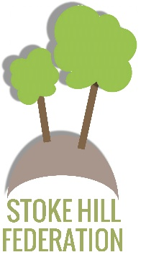

### *‘Somewhere, something incredible is waiting to be known.”*

### *Carl Sagan*

Year 1 Learning Letter – Autumn 2021