Nursery Children – Have a sound talk tea party

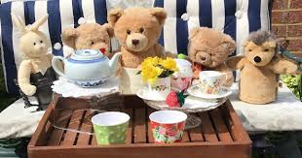

Adult, pretend a toy is whispering in your ear in ‘sound talk’, for example whisper “What would teddy like to eat?”
The toy speaks into the adult’s ear and the adult repeats ‘ch- ee-se’.
The child blends the sounds and says the word, ‘cheese’.

h-a-m | b-u-n | m-i-l-k | a-pp-le
j-a-m | p-l-u-m | p-ear | e-gg

