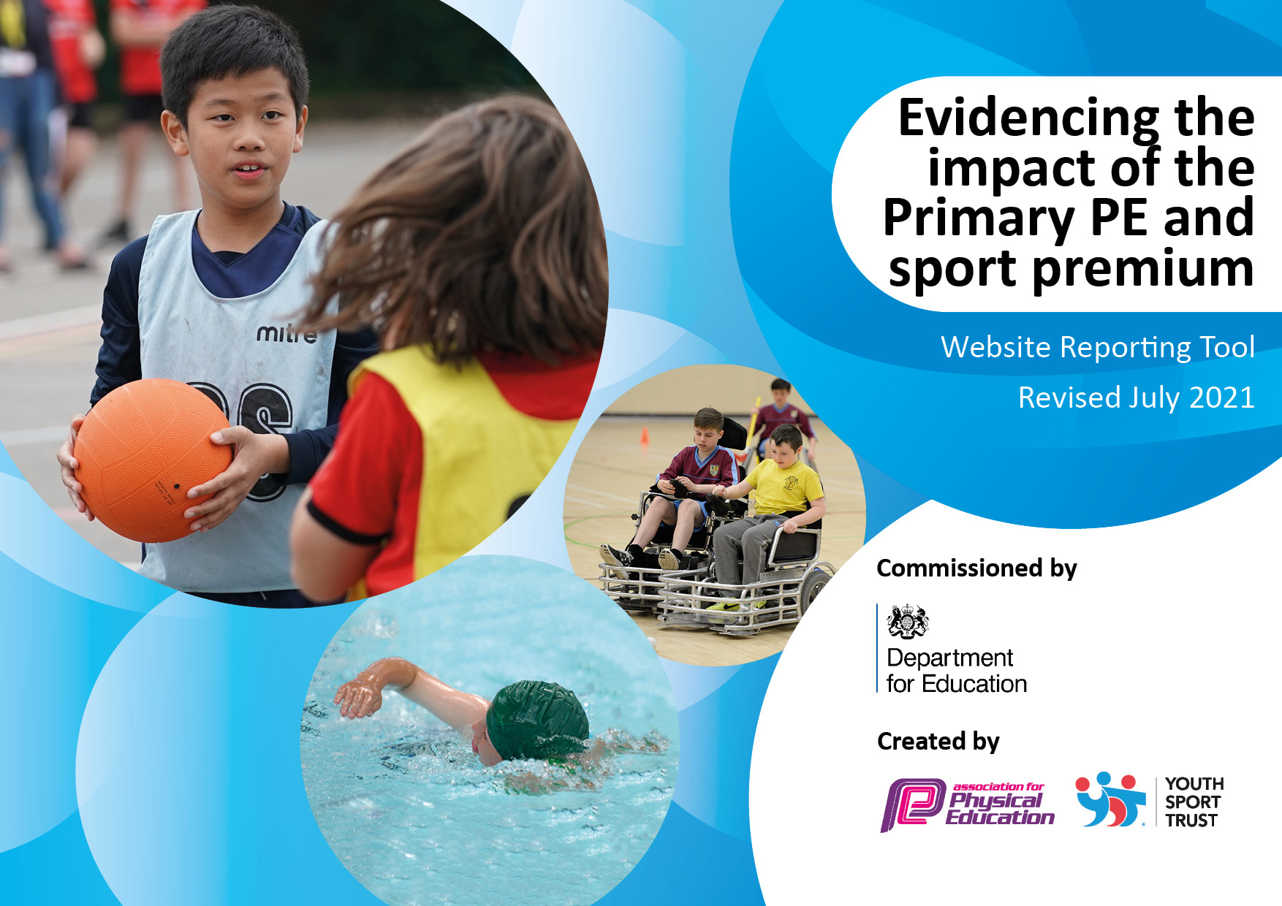

It is important that your grant is used effectively and based on school need. The Education Inspection Framework makes clear there will be a focus on ‘whether leaders and those responsible for governors all understand their respective roles and perform these in a way that enhances the effectiveness of the school’.

Under the Quality of Education Ofsted inspectors consider:
Intent - Curriculum design, coverage and appropriateness
Implementation - Curriculum delivery, Teaching (pedagogy) and Assessment
Impact - Attainment and progress

To assist schools with common transferable language this template has been developed to utilise the same three headings which should make your plans easily transferable between working documents.

Schools must use the funding to make additional and sustainable improvements to the quality of Physical Education, School Sport and Physical Activity (PESSPA) they offer. This means that you should use the Primary PE and sport premium to:

- Develop or add to the PESSPA activities that your school already offer
- Build capacity and capability within the school to ensure that improvements made now will benefit pupils joining the school in future years
- The Primary PE and sport premium should not be used to fund capital spend projects; the school’s budget should fund these.

Pleasevisitgov.ukfortherevisedDfEguidanceincludingthe5keyindicatorsacrosswhichschoolsshoulddemonstrate animprovement.Thisdocumentwillhelpyoutoreviewyourprovisionandtoreportyourspend.DfEencouragesschools to use this template as an effective way of meeting the reporting requirements of the Primary PE and sport premium.

We recommend you start by reflecting on the impact of current provision and reviewing the previous spend.

Schools are required to publish details of how they spend this funding, including any under-spend from 2019/2020, as well as on the impact it has on pupils’ PE and sport participation and attainment. All funding must be spent by 31st July 2022.

We recommend regularly updating the table and publishing it on your website throughout the year. This evidences your ongoing self-evaluation of how you are using the funding to secure maximum, sustainable impact. Final copy must be posted on your website by the end of the academic year and no later than the 31st July 2021. To see an example of how to complete the table please click HERE.

Details with regard to funding
Please complete the table below.

Total amount carried over from 2020/21
Total amount allocated for 2021/22 | £17795.00
How much (if any) do you intend to carry over from this total fund into 2022/23? | £7800.00
Total amount allocated for 2021/22 | £9795.00
Total amount of funding for 2021/22. To be spent and reported on by 31st July 2022. | £9795.00

Action Plan and Budget Tracking
Capture your intended annual spend against the 5 key indicators. Clarify the success criteria and evidence of impact that you intend to measure to evaluate for pupils today and for the future.

Academic Year: 2020/21 | Total fund allocated: | Date Updated:
Key indicator 1: The engagement of all pupils in regular physical activity – Chief Medical Officers guidelines recommend that primary school pupils undertake at least 30 minutes of physical activity a day in school |  |  |  | Percentage of total allocation:
 |  |  |  | 49%
Intent | Implementation |  | Impact
Your school focus should be clear what you want the pupils to know and be able to do and about  what they need to learn and to  consolidate through practice: | Make sure your actions to achieve are linked to your intentions: | Funding allocated: | Evidence of impact: what do pupils now know and what can they now do? What has changed?: | Sustainability and suggested next steps:
Physical break to engage all pupils in DPA for KS1 children each afternoon  Children to have the opportunity to take part in play that will encourage them to practise and development fundamental movements and encourage active playtimes/healthy lifestyles.  Maintenance work to update existing playground equipment | Provision during afternoon playtimes to reflect what is offered during morning and lunch breaks.  Purchase new playground equipment to include trikes, scooters and other smaller equipment to support gross motor development.  Gather quotes from companies to carry out the work.  Look for external funding to meet the extra costs. | £0  £1000.00  £7800.00 (funding to be carried over into 2021/22) | - Children to access 30 mins of physical activity during the school day.  - Children will be engaged in very active playtimes and lunchtimes.  - Completion of a well used resource so that all components are of good quality and able to be fully accessed by pupils.
Key indicator 2: The profile of PESSPA being raised across the school as a tool for whole school improvement |  |  |  | Percentage of total allocation:
 |  |  |  | 36%
Intent | Implementation |  | Impact
Your school focus should be clear what you want the pupils to know and be able to do and about  what they need to learn and to  consolidate through practice: | Make sure your actions to achieve are linked to your intentions: | Funding allocated: | Evidence of impact: what do pupils now know and what can they now do? What has changed?: | Sustainability and suggested next steps:
Play Leaders to be able to support pupils play and physical activity by leading and engaging the children in structured physical activity at lunchtimes.  Pupils will participate in a termly physical event. At least one to be linked to national sporting initiatives – My Step (BHF), School Sport’s week. | - Play Leaders will have a bank of games to initiate and play with children at lunchtimes.  - Planned events across each term beginning Spring 2022.  - Link summer term events to competitive Sport’s Day | £6412.00  £0 | - Pupils will begin to learn some games that they may be able to learn and implement independently.  - Pupils will have access to games that promote practise of fundamental movement skills.

Key indicator 3: Increased confidence, knowledge and skills of all staff in teaching PE and sport |  |  |  | Percentage of total allocation:
 |  |  |  | 12%
Intent | Implementation |  | Impact
Your school focus should be clear | Make sure your actions to | Funding | Evidence of impact: what do | Sustainability and suggested
what you want the pupils to know | achieve are linked to your | allocated: | pupils now know and what | next steps:
and be able to do and about | intentions: |  | can they now do? What has
what they need to learn and to |  |  | changed?:
consolidate through practice:
Introduce new P.E. curriculum package.  Review quality of P.E. resources on offer and replace any that are no longer fit for purpose to improve the PE provision. | - Audit teachers subject knowledge around P.E., identify particular needs.  - Purchase new P.E. curriculum support with clear resources, training and progression.  - Purchase new P.E.resources to support the curriculum and update existing resources. | £1995.00  £200.00 | - Teachers are confident to teach P.E.  - P.E. curriculum has a clear progression based upon developing key fundamental movement.  - Children’s skill levels improve.  - Children will have access to high quality images and resources.
Key indicator 4: Broader experience of a range of sports and activities offered to all pupils |  |  |  | Percentage of total allocation:
 |  |  |  | 2%
Intent | Implementation |  | Impact
Your school focus should be clear | Make sure your actions to | Funding | Evidence of impact: what do | Sustainability and suggested
what you want the pupils to know | achieve are linked to your | allocated: | pupils now know and what | next steps:
and be able to do and about | intentions: |  | can they now do? What has
what they need to learn and to |  |  | changed?:
consolidate through practice:
Children to be able to experience sport opportunities outside of school hours that they may not otherwise have access to. | Autumn Term - contact external sports providers to see what opportunities there are for infant age children. Agree costs and timetable. | £300.00 | - Children will have the opportunity to try a sport that they may not otherwise access.  - Increase in children’s participation in physical activity after school.

Key indicator 5: Increased participation in competitive sport |  |  |  | Percentage of total allocation:
 |  |  |  | 0%
Intent | Implementation |  | Impact
Your school focus should be clear | Make sure your actions to | Funding | Evidence of impact: what do | Sustainability and suggested
what you want the pupils to know | achieve are linked to your | allocated: | pupils now know and what | next steps:
and be able to do and about | intentions: |  | can they now do? What has
what they need to learn and to |  |  | changed?:
consolidate through practice:
Children to be able to learn about competitive sport through annual Sport’s Day – focus on improving a personal best time or score.  Pupils and families to be made aware of local community sports clubs that children could access. | - Review current practise around Sports Day and liase with staff about making changes linked to competitive sport. Use YST information on School Sport’s Week.  - Organise termly school wide competitive sponsored event – BHF My Step, ‘Bouncathon’  - Include links to local sports clubs/events in school newletter. | £0  £0  £0 | - Children able to talk about their personal best and how to improve it.  - Participation of all pupils in school wide events with an element of competition.  - Impact to be monitored through feedback from families – Summer 2022.

Signed off by
Head Teacher:
Date:
Subject Leader:
Date:
Governor:
Date:

