Mindfulness
Mindfulness is a really simple idea. It is about paying attention. The part of the brain that is in charge of your attention keeps you aware of what is happening inside you and around you. In mindfulness the idea is to try and focus on one thing at a time. This can sometimes be really tricky to do because we are used to having busy thoughts going around our minds. Sometimes we need to have a break from having all those thoughts whizzing around our heads and that is what mindfulness is all about.
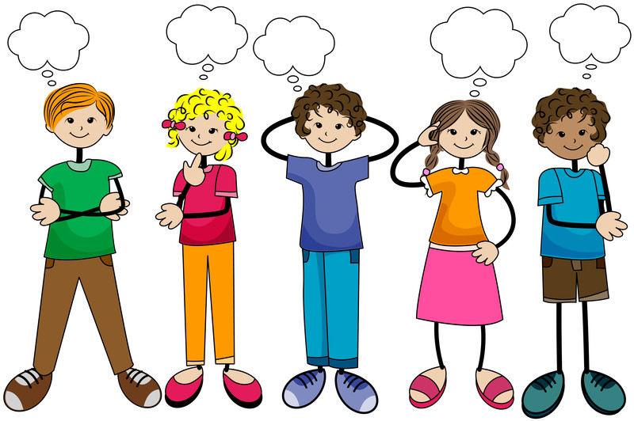

There are many ways to practice mindfulness, but we are going to be looking at two of them.
- Breathing Exercises

- Superhero Poses

Breathing Exercises

Breathing exercises are really good at getting us to focus on one thing: our breathing. It is something that happens automatically to us, we very rarely think about it, so by just focusing on your breathing, it helps us to be calm and let all other thoughts and emotions come and go.

Balloon Belly:
- Lay down in a warm, comfortable, and quiet place.
- Pretend that your belly is like a balloon.
- Take in a slow, strong breath.
- Notice how the balloon gets bigger as it inflates with air.
- Slowly breath out.
- Pay attention to how the balloon gets smaller as it deflates.
- Take a few moments to practice slowly inflating and deflating your balloon.
(You could put a teddy on your belly and watch the teddy go up and down)

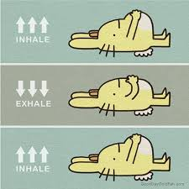

Hot Chocolate:

- In a nice quiet room stand up tall, with your shoulders down away from your ears.
- Pretend you are holding a mug of hot chocolate between both of your hands.
- Pretend to bring the mug up towards your face.
- Take a slow breath in for 1, 2, 3, 4, 5. Imagine you are smelling the yummy comforting chocolate smell.
- Slowly, gently, breath out for 1, 2, 3, 4, 5. Pretending to blow the steam from the hot chocolate to cool it.
- Repeat five or six times.

Hug Tight:
- In a nice quiet room, you can either sit tall cross legged on the floor or stand nice and tall.
- Spread your arms nice and wide either side of you. Put your head up a little and take a deep breath in.
- Breathe out and put your arms around yourself. Give yourself a hug. Move your head so you are looking down and close your eyes if you would like to.
- Repeat this 5 or 6 times.
(This is a really lovely one to do right now. You might be missing cuddles and hugs from people you would normally see: friends, grandparents, cousins etc. So you can think about them whilst you are doing your Hug Tight breathing).
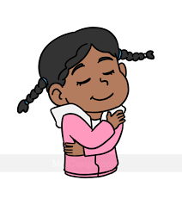

Superhero Poses
These are great for getting you to focus on what your body is doing and to have a break from our busy minds.
Have a think how you feel before you do the poses and then after.
These poses will help make you feel strong, brave and happy!

The Superman / Wonder Woman: Stand up tall with your legs slightly wider than your hips. Put your hands on your hips and head looking slightly up. Take a deep breath in for 1, 2, 3, 4, 5 and then a breath out for 1, 2, 3, 4, 5. Repeat 3 times and see how you feel.

The Spidey Senses: Get into your best Spiderman pose (make sure it is one you can stay in for a few minutes). Turn on your Spidey Senses and focus on what you hear, what you can see, what you can smell, what you can taste and what you can feel or touch. Pause on each sense and really focus on that thing before moving onto the next one.
