Stoke Hill Federation

Weekly Update 27.4.20

We hope that all is well with your family during week 3 of the summer term, and that learning at home, however you are managing this, is settling into a routine of sorts.

School re-opening remains uncertain, but no doubt will be much debated!

However, for now, whilst in lockdown, the Government guidance re COVID-19 remains the same:

- Only go outside for food, health reasons or work (but only if you cannot work from home)
- If you go out, stay 2 metres (6ft) away from other people at all times
- Wash your hands as soon as you get home
- Do not meet others, even friends or family
- Remember you can spread the virus even if you do not have symptoms

The schools and the nursery remain closed, continuing to support parents of key workers who absolutely need childcare arrangements only.

Online Learning
We are working with our colleagues in the River Exe Learning Partnership and are all giving this consistent message to our families about home learning.

We understand the complexity of the home working day and want to give you as many opportunities to help your children at home as we can, but please do not feel that you need to complete everything that is being sent to you.
We appreciate that ‘learning at home’ can feel like an impossible task and that you are not teachers, neither are your homes set up as classrooms. The activities on the website are just a guide. We know how busy you must be during this time, so please do not feel that all the learning sent out has to be finished.
Do not feel worried that your children might be missing out on their learning at the moment. This will only add to the stress that you are all under and can often lead to you and your child being put off learning, which isn’t beneficial for anyone.
If there are any gaps in learning that might need to be supported as a result of this time away from school, we will do everything possible to work with you to address this when we get back. All children and schools are facing the same challenges, and we will have the resources and a fabulous team of experienced staff to support you and your child when schools start to re-open again.

Help and Support

Guided Reading Books
Feedback from infant school families has been that accessing ‘levelled’ reading books is limited and titles on Oxford Owl have been quickly read. Here are 3 other book suggestions:

1) There are some companies that offer 30/90-day free trials of levelled books, but please be wary of the ongoing financial commitment it you forget to cancel to or are unable to end the trial period successfully.

2) This is FREE and great, if you are interested you may wish to look at the ‘Big Cat’ phonics books https://collins.co.uk/pages/big-cat-ebooks You will be provided with a password and log on – go through the teacher portal to find books at your child’s reading level.

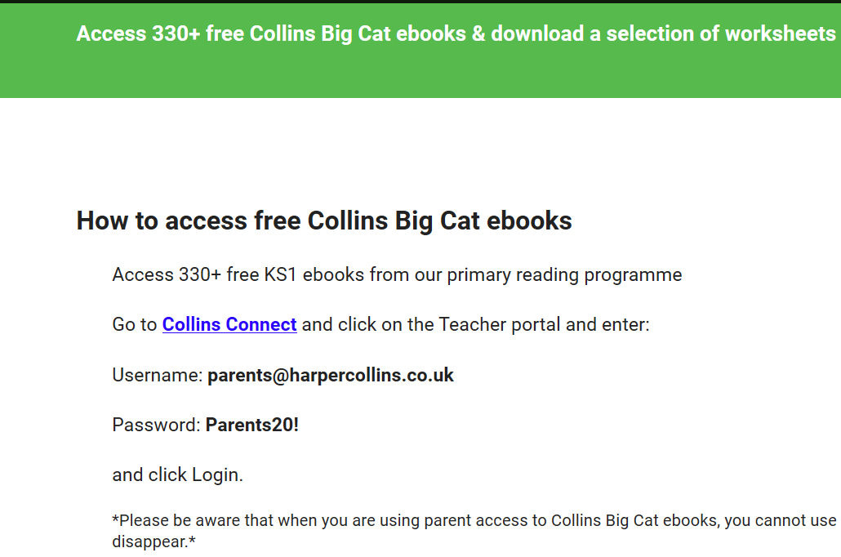

3) If you are able to plan your ‘daily walk’ to pass the school gates during the day, from tomorrow you will find a colourful storage tower containing Guided Reading books that we have spare + antibac wipes for use if you loan/return a book. The book tower will be by the front door to the nursery, under their porch. You are welcome to borrow a book, please take one book at a time, and return, hope that helps a bit.

Free School Meals
If your circumstances have changed you may be entitled to free school meals. You can find out if this is the case by visiting the Citizen Portal which is the oneonline.devon.gov.uk facility for checking. Visiting the portal is the quickest and easiest way to apply and will result in you getting an instant decision. Becoming eligible will mean that we will be able to provide you with a weekly Food Hamper or, once we are successfully set up, a £15 supermarket e-voucher.

Contact
Your child’s teacher’s email address is available on the website if you need to contact them for any reason. They are hoping to hear from every child, every week, just a message, or a photo or some learning if you like.

I am also happy to answer any queries. You can contact me directly at sarah.mackay@stokehill.devon.sch.uk

Take care, kind regards,

Sarah Mackay

