Year 5 Curriculum Spring Term 2020

We thought you would find it useful to have a clear idea about the skills and vocabulary your child has been learning since we came back after Christmas, and to have some information about the rest of the spring term. The information below is, of course, only a starting point, and they will learn much more than we have written down!

Key Learning: English and maths
Reading | Writing | Maths
- Continuing to read and discuss an increasingly wide range of fiction, poetry, plays, non-fiction and reference books or textbooks.  - Increasing their familiarity with a wide range of books, including myths, legends and traditional stories, modern fiction, fiction from our literary heritage, and books from other cultures and traditions.  - Discuss and evaluate how authors use language, including figurative language, considering the impact on the reader.  Participate in discussions about books that are read to them and those they can read for themselves, building on their own and others’ ideas and challenging views courteously. | - Use dialogue to move the story on.  - Use a range of multi-clause sentences.  - Use a range of punctuation to separate clauses.  - Use rich and varied vocabulary.  Start sentences in a variety of ways. | Multiplication & Division:  - Multiply and divide numbers mentally drawing upon known facts.  - Multiply numbers up to 4 digits by a one or two digit number using a formal written method, including long multiplication for 2-digit numbers.  - Divide numbers up to 4 digits by a 1- digit number using the formal written method of short division and interpret remainders appropriately for the context.  - Solve problems involving addition and subtraction, multiplication and division and a combination of these, including understanding the use of the equals sign.  Fractions:  - Compare and order fractions whose denominators are multiples of the same number.  - Identify, name and write equivalent fractions of a given fraction, represented visually including tenths and hundredths.  Recognise mixed numbers and improper fractions and convert from one form to the other and write mathematical statements >1 as a mixed number [for example 2/5 + 4/5 = 6/ 5 = 1 and 1/5]

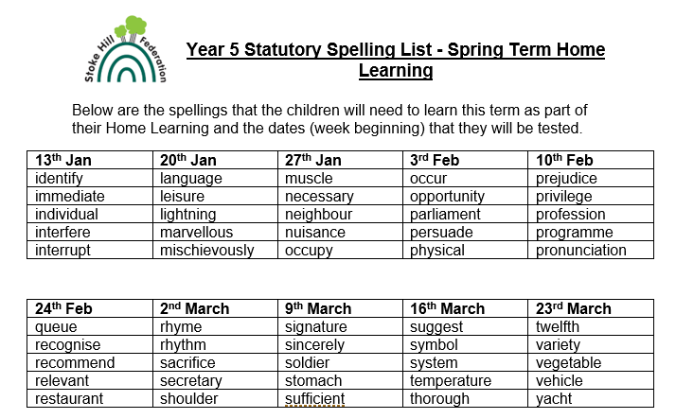

Whole Class Guided Reading texts
- The Hobbit
- The Railway Children
- Peter Pan
- Colonel Fazakerley Butterworth-Toast
- Tom’s Midnight Garden
- Jungle Book
- Tin-Tin

Online Safety
Tuesday 11th February = Safer Internet Day
1Decision unit (Computer Safety)

Spring Term Key Vocabulary and Skills

This is a brief overview of some of the vocabulary the children will learn this term. It is the minimum we expect all of the children to know and understand well by Easter.

Art - Painting
Vocabulary | Skills
Landscape – everything you can see across an area of land  Blended – mixing different things together  Reflected – when you see its image repeated in something  Focus – pay attention to something  Vibrant - pulsating with vigour and energy. | Use sketchbooks to record observations and use them to review and revisit  Create paintings inspired by landscapes, themes, music and poetry using acrylics and watercolours  Create prints with three overlays  Learn about a great painter

DT Design – Make – Evaluate
Sewing 2
Vocabulary | Skills
Modification – to change the plan  Fasten – connect or attach two or more things  Tack – short nail with a broad flat head  Design - to plan or make a detailed plan of something  Evaluate - consider something to make a judgement about it | Assess and modify, accurately measure, mark out and cut, Sew e.g. Back-stitch/ overstitch  Use tools safely and accurately

Human and Physical Geography
Locational Knowledge
Regions within the UK – land use, patterns and how these have changed over time
Vocabulary | Skills
Characteristics – qualities that make something recognizable  Region – a large area of land  Names and locations of UK regions  Human geographical features - places are recognized by their human characteristics  Spatial variation – a quantity that is measured across locations | Understand the processes that give rise to key human geographical features of the world, how these are interdependent, and how they bring about spatial variation and change over time

RE What does it mean to be a Muslim in Britain today?
Vocabulary | Skills
Mecca/Makkah - a city in Saudi Arabia, which is the holiest city in Islam because the Prophet Mohammed was born there.  Pilgrimage - a journey that someone makes to a place that is very important to them.  Hajj – Muslim pilgrimage to Mecca/Makkah  Zakah/Zakat – one of the Five Pillars of Islam – giving money to charity to help the poor and needy  Hadith - words, actions and instructions of the Prophet Muhammad reported by the people around him during his life | Make connections between Muslim beliefs studied and Muslim ways of living in Britain/your region today  Consider and weigh up the value of e.g. submission, obedience, generosity, self-control and worship in the lives of Muslims today and articulate responses on how far they are valuable to people who are not Muslims

Music
Vocabulary | Skills
Prepare and perform the Y5 Production (next term) | Play and perform in an ensemble using their voices and playing musical instruments

PE 1.Gymnastics 2. Swimming
Vocabulary | Skills
Gymnastics  Apparatus - equipment, such as horizontal bars, trampolines or the balls and ribbons used in rhythmic gymnastics  Balance – the ability to keep your body steady and upright  Handstand – a position with your hands on the ground while your body and legs are upright in the air  Landing – the last part of a dismount when your feet hit the ground  Twist - a movement in which part of the body, or the whole body, turns round  Swimming  Dolphin Kick – a rhythmic leg movement only used in the butterfly stroke.  Lap - the distance from one end of a swimming pool to the other.  Medley - a race that includes one or more laps in each of four swimming styles.  Starting Block - a small platform each swimmer dives from at the start of a race.  Touch Pad - an underwater electronic pad that competitors touch at the end of each lap. | Uses turns whilst travelling in a variety of ways.  Beginning to show flexibility in movements.  Swims competently, confidently and proficiently over a distance of at least 25 metres  Uses a range of strokes effectively e.g. front crawl, backstroke and breaststroke.

Science Animals, including humans
Vocabulary | Skills
Infant – a baby or a very young child  Puberty – the stage in someone’s life when the body starts to become physically mature  Gestation – the process where babies grow inside their mother’s body | Explore and talk about their ideas; asking their own questions about scientific phenomena; and analysing functions, relationships and interactions more systematically.  Recognise that scientific ideas change and develop over time.  that has been used to support or refute ideas or arguments

Science Forces
Vocabulary | Skills
Friction - Friction is a 'sticking' force – the resistance that a surface or object encounters when moving over another surface or object.  surface resistance  Gravity - Gravity is the pulling force acting between the Earth and a falling object. Gravity pulls objects to the ground.  air resistance - Air resistance is the force on an object moving through air. Air resistance affects how fast or slowly objects move through the air.  water resistance - Water resistance is the force on objects floating on or moving in water.  simple machines - Simple machines work by turning small forces into larger ones, allowing us to perform tasks with more strength or speed. Examples of simple machines are levers, gears, pulleys, wheels and screws. | Planning different types of scientific enquiries to answer questions, including recognising and controlling variables where necessary.  Taking measurements, using a range of scientific equipment, with increasing accuracy and precision, taking repeat readings when appropriate.  Recording data and results of increasing complexity using scientific diagrams and labels, classification keys, tables, scatter graphs, bar and line graphs.  Using test results to make predictions to set up further comparative and fair tests.

Home Learning
We would like all children to read their Accelerated Reader book as often as they can, but at least three times a week for about 20 minutes a time. They need to learn their spellings. We would also like them to spend time practising their maths skills using Mathletics and TTRockstars.

