Pupil premium strategy statement

This statement details our school’s use of pupil premium (and recovery premium for the 2021 to 2022 academic year) funding to help improve the attainment of our disadvantaged pupils.

It outlines our pupil premium strategy, how we intend to spend the funding in this academic year and the effect that last year’s spending of pupil premium had within our school.

School overview
Detail | Data
School name | Stoke Hill Infant + Nursery School
Number of pupils in school | 291
Proportion (%) of pupil premium eligible pupils | (19/291) 6.5%
Academic year/years that our current pupil premium strategy plan covers (3 year plans are recommended) | 2021/22
Date this statement was published | November 2021
Date on which it will be reviewed | November 2022
Statement authorised by | Yvonne Hammerton-Jackson
Pupil premium lead | Claire McKimm
Governor / Trustee lead | Amy Bickford
Funding overview
Detail | Amount
Pupil premium funding allocation this academic year | £28145  £2345 (Post LAC)
Recovery premium funding allocation this academic year | £3045
Pupil premium funding carried forward from previous years (enter £0 if not applicable) | £ 0
Total budget for this academic year  If your school is an academy in a trust that pools this funding, state the amount available to your school this academic year | £ 33,535

Part A: Pupil premium strategy plan

Statement of intent
At Stoke Hill our intention is that all pupils, irrespective of their background or the challenges they face, make good progress and achieve high attainment across all subject areas. The focus of our pupil premium strategy is to support disadvantaged pupils to achieve that goal, including progress for those who are already high attainers.
We will consider the challenges faced by vulnerable pupils, such as those who have a social worker and young carers. The activity we have outlined in this statement is also intended to support their needs, regardless of whether they are disadvantaged or not.
High-quality teaching is at the heart of our approach, with a focus on areas in which disadvantaged pupils require the most support. This is proven to have the greatest impact on closing the disadvantage attainment gap and at the same time will benefit the non-disadvantaged pupils in our school. Implicit in the intended outcomes detailed below, is the intention that non-disadvantaged pupils’ attainment will be sustained and improved alongside progress for their disadvantaged peers.
Our approach will be responsive to common challenges and individual needs, rooted in robust diagnostic assessment, not assumptions about the impact of disadvantage. The approaches we have adopted complement each other to help pupils excel.
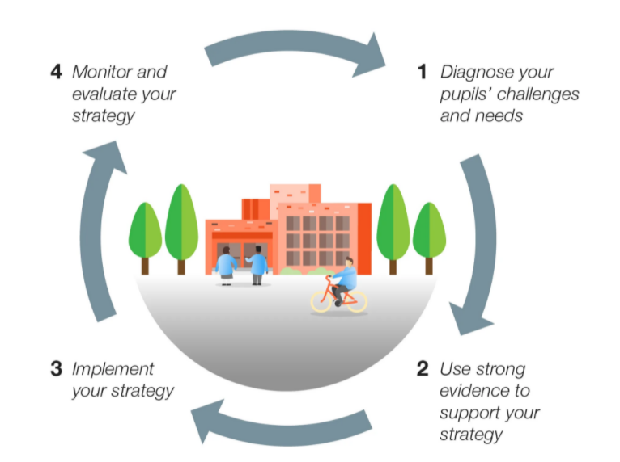
Our pupil premium strategy is cyclical and fully integrated within our wider Federation Improvement Plan.

We use the EEF model to help us plan strategically across the Infant and Junior school to ensure Stoke Hill families benefit from a consistent and impactful approach to Pupil Premium spending.

Challenges

This details the key challenges to achievement that we have identified among our disadvantaged pupils.
Challenge number | Detail of challenge
1 | Speech, Language and communication skills
2 | Persistent absence and lateness
3 | Wellbeing
4 | Family support

Intended outcomes
This explains the outcomes we are aiming for by the end of our current strategy plan, and how we will measure whether they have been achieved.
Intended outcome | Success criteria
1 Quality first teaching underpins SEND / PP approach in all classrooms. Where necessary children are identified early and supported quickly with focused speech and phonics interventions. Sp&L specialist training to be brought into school to train teachers and TAs. | PP children with Sp&L needs are identified quickly and monitored closely to ensure gaps do not open and children progress well from their individual starting points.
2 PP children attend school regularly, feel part of the class community, do not miss out on learning and wider school experiences. Their attendance is closely monitored and families are supported quickly to address ongoing concerns. | PP children attend school in line with or more than non pp children. PP children enjoy attending school and families understand the importance of, and are invested in, regular school attendance.
3 Improvement in emotional wellbeing and behaviour of all PP children. PP children’s social and emotional skills improve in order to retain friendships and increase cooperation. Children develop resilience to cope with life post Covid and possible further disruption | PP children use well-being strategies to enable them to make accelerated academic progress and are ready to learn with the aim that PP children are working at ARE or above at the end of the school year.
4 Families in need of additional support are able to access this through the school’s Family Support Worker to ensure children make expected or better progress based on their individual starting point. | Families feel supported by appropriate agencies. Improved engagement with school e.g. attends parents’ evenings and school events etc. Families feel confident supporting their children and work with the school to ensure the best outcomes for the children.

Activity in this academic year
This details how we intend to spend our pupil premium (and recovery premium funding) this academic year to address the challenges listed above.

Teaching (for example, CPD, recruitment and retention)
Budgeted cost: £ 12,435
Activity | Evidence that supports this approach | Challenge number(s) addressed
Purchase of standardised diagnostic assessments.  Training for staff to ensure assessments are interpreted and administered correctly. | Standardised tests can provide reliable insights into the specific strengths and weaknesses of each pupil to help ensure they receive the correct additional support through interventions or teacher instruction:  Standardised tests | Assessing and Monitoring Pupil Progress | Education Endowment Foundation | EEF  PIRA/PUMA/NFER resources to be reviewed, purchased and embedded. | 1, 2, 3, 4
Purchase of a DfE validated Systematic Synthetic Phonics programme to secure stronger phonics teaching for all pupils. Little Wandle package to be established Jan 2022. | Phonics approaches have a strong evidence base that indicates a positive impact on the accuracy of word reading particularly for disadvantaged pupils:  Phonics | Toolkit Strand | Education Endowment Foundation | EEF | 1,2
Improve the quality of social and emotional (SEL) learning.  SEL approaches will be embedded into routine educational practices and supported by professional development and training for staff.  Jigsaw curriculum established Sept 2021 | There is extensive evidence associating childhood social and emotional skills with improved outcomes at school and in later life  EEF_Social_and_Emotional_Learning.pdf(educationendowmentfoundation.org.uk) | 3,4
Quality first teaching approach raises the standard of our universal offer.  Training and monitoring costs are also considered. | The best available evidence indicates that great teaching is the most important lever schools have to improve outcomes for their pupils.  https://educationendowmentfoundation.org.uk/support-for-schools/school-improvement-planning/1-high-quality-teaching | 1,3

Targeted academic support (for example, tutoring, one-to-one support structured interventions)
Budgeted cost: £ 9,750
Activity | Evidence that supports this approach | Challenge number(s) addressed
Additional phonics sessions targeted at disadvantaged pupils who require further phonics support. This will be delivered in line with the new phonics system Little Wandle and includes release time for TA training. | Phonics approaches have a strong evidence base indicating a positive impact on pupils, particularly from disadvantaged backgrounds. Targeted phonics interventions have been shown to be more effective when delivered as regular sessions over a period up to 12 weeks:  Phonics | Toolkit Strand | Education Endowment Foundation | EEF | 1
Additional adults deployed across the school to focus on gaps in learning for all children. Leaders focus on PP children when putting together interventions.  Training and monitoring costs are also considered. | Access to high quality teaching is the most important lever schools have to improve outcomes for their pupils. It is particularly important to ensure that when pupils are receiving support from a teaching assistant, this supplements teaching but does not reduce the amount of high-quality interactions they have with their classroom teacher both in and out-of-class.  Teaching Assistant Interventions | EEF (educationendowmentfoundation.org.uk) | 1,3
Engaging with the National Tutoring Pro-gramme to provide a blend of tuition, mentoring and school-led tutoring for pupils whose education has been most impacted by the pandemic. A significant proportion of the pupils who receive tutoring will be disadvantaged, including those who are high attainers. | Tuition targeted at specific needs and knowledge gaps can be an effective method to support low attaining pupils or those falling behind, both one-to-one:  One to one tuition | EEF (educationendowmentfoundation.org.uk)  And in small groups:  Small group tuition | Toolkit Strand | Education Endowment Foundation | EEF | 1,3.4

Wider strategies (for example, related to attendance, behaviour, wellbeing)
Budgeted cost: £ 12,350
Activity | Evidence that supports this approach | Challenge number(s) addressed
Whole staff training on behaviour management and anti-bullying approaches with the aim of developing our school ethos and improving behaviour across school. | Both targeted interventions and universal approaches can have positive overall effects:  Behaviour interventions | EEF (educationendowmentfoundation.org.uk) | 3
Embedding principles of good practice set out in the DfE’s Improving School Attendance advice.  This will involve training and time for Head of Inclusion, admin staff and Family Support Worker to develop and implement new procedures. | The DfE guidance has been informed by engagement with schools that have significantly reduced levels of absence and persistent absence. | 2,3,4
Wrap around care - breakfast provision is offered to PP families to support childcare/working parents. | PP families are better supported throughout the school day. Breakfast club provision ensures identified children are well prepared for the school day. | 2,3,4
Federation Family Support worker employed across both Infant and Junior schools to consistently support vulnerable families. | Providing early support for families across the Federation has proven to break down barriers and improve outcomes for children and families. | 2,3,4
Subsidised trips, uniform and priority access given to teacher led clubs to ensure PP children are always at the forefront of our minds. | Equality and access to school experiences is essential to wellbeing and development of all children. | 2,3,4

Total budgeted cost: £ 34,535

Part B: Review of outcomes in the previous academic year

Pupil premium strategy outcomes
This details the impact that our pupil premium activity had on pupils in the 2020 to 2021 academic year.
What we said we would do (priorities) | What we have done (implementation) | What difference has it made (impact)
EYFS/KS1 Quality First Teaching | Refresh through literature and team discussion the principles of QFT.  QFT checklist shared with staff in April  Retrieval practice PDMs (May, June)  Shared “Why I prefer pre-teaching to remediation…” Justin Minkel | Classroom offer addresses barriers to learning and helps all pupils make progress against their starting points.
KS1 Ensure maximum time for  basic skills | Use the ‘Getting Back on Track’ strategy to  a) undertake a review of curriculum content b) review available time. Increase teaching time in phonics, English and maths. Ensure that basic skills are practised across all subjects e.g. as part of project learning. | Core subjects were prioritised in timetabling whilst allowing balance to promote wellbeing and help address gaps created by Covid.  Core skills embedded in other subjects.
EYFS/KS1 Phonics | Ensure phonic assessment follows best practise.  Refresh through CPD phonic subject knowledge for all staff. | Whole class teaching and targeted intervention helped most pupils achieve expected outcomes.
EYFS/KS1 Feedback & Marking | Refresh through CPD the pedagogy and policy for feedback and marking. | Children know what to do to improve their learning, leading to increased progress.
EYFS/KS1 Developing Vocabulary Project (DVP) | Refresh through CPD the key principles of the DVP. Undertake monitoring of PPG children and the environment. Re-engage with the LA advisor support for the DVP.  English and maths  Science (May) | Enabled focus on language and teachers report PP children using more tier 2 vocabulary.
FS/KS1 Maths | Refresh through CPD key images and language for the teaching of number in maths | More effective use of pre-teaching means children are more able to independently access their learning and make progress in lessons.
Children pass the Phonic Check in Y1 and Y2 | Y2 Phase 3 Remediation  Y1 Phase 2 Remediation  Y2 Phase 5 Remediation  Y1 Phase 3 Remediation  Y1 & Y2 Phase 5 Booster | Most PP children passed the phonics check  91% of Y2 children had passed the phonics check on exit
EYFS and KS1 Targeted in class support | Teacher focuses their attention on the lower attaining children in English, phonics, handwriting, maths, reading and writing lessons whilst the TA supports the other children.  CPD in April | Narrowing the gap between PP and non  Pupil voice demonstrates the impact of small group tutoring and has driven a school improvement priority for 2021/22 – Talk for Writing  How it helps:  “because she writes it first”  “we used word cards, have a go strategies and then we do it after”  “all the things the teacher says are the things you want to know”  “I can find numbers quickly on a hundred square now… and I know my number bonds and now I get my numbers round the right way”  “helping me with ideas for writing and it makes it easier for me to write in class”
STEPS – Thrive based 1:1 support | Based on assessed need. | Whole school wellbeing focus helped the transition back to school, addressed worries created by lockdown, promoted positive social interactions and got children ready for school-based learning
Education Support Worker | Works with families to overcome barriers to educational achievement. | Helps break down barriers to learning; supported with food parcels; regular contact and emotional support
FREE Breakfast and After School club | Offered to all families, whether working or in need. | Gives children a positive start to the day so that they are ready to access their learning
Subsidies | For uniform and educational visit costs. | Helps children be ready for learning and feel comfortable and part of the community
Enrichment | Provide opportunities for disadvantaged children to have wider experiences and enrichment. | Targeted for cultural enrichment opportunities e.g. community events, helping them feel like they are active and valued members of the community

