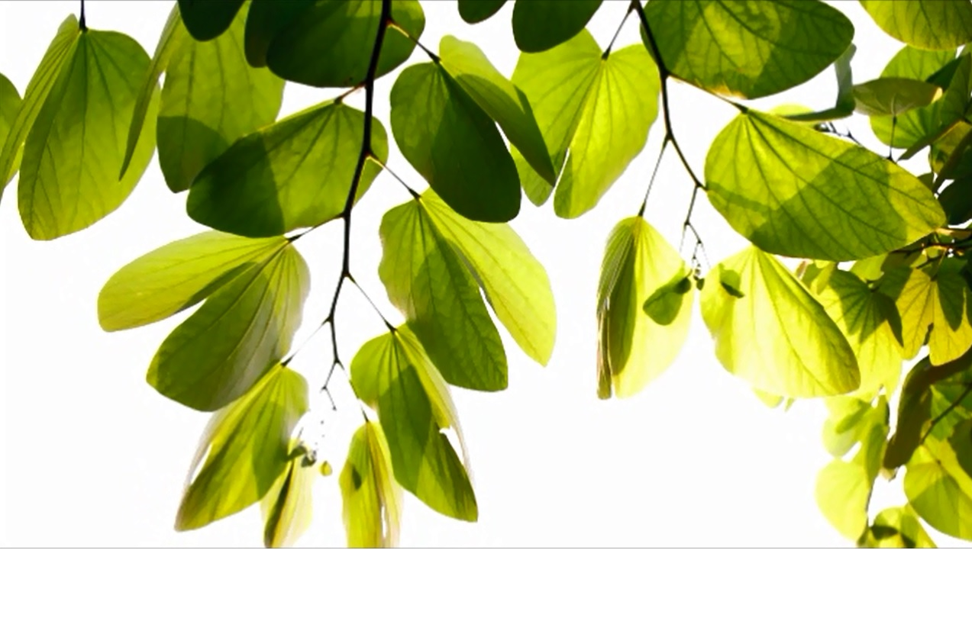

**Year 1**

**Autumn Home Learning**

**ESSENTIAL each week:**

**Reading**

x3 sessions of up to 10-15 minutes reading the Guided Reading book. Please share your week of reading by writing in the Guided Reading Record.

**Maths**

x3 sessions of up to 10 minutes practising the current maths skills that your teacher has selected for the class on Education City**.** You should already have your login details. Do ask the class teacher if you need a reminder.

**OPTIONAL to enjoy over the**

**Autumn Term** *to further support your child’s learning and skills. How much time to spend of each task will depend on the activity. A good rule to go by is… enough time to enjoy but not too much time to make learning a chore.*

**Draw:** When building or creating something at home draw a design first to plan your ideas.

**Research:** A country which is special to you and compare the climate and landscape to where you live.

**Visit:** The local park and look for sign or Winter. What materials can you find?

**Go to:** The local library and find some more stories about wishes. How are they the same and different to our story.

~~~~

Year 1 Learning Letter

This Half Term’s Projects

Our new project is called ‘What would you wish for?’ This half term we will enter the world of magical wishes. On our adventures we will explore interesting places and objects along the way. As part of D&T and Art and Design we will design and make our own lamps and we will end the term with the Year 1 Nativity, to which you are all invited. Details to follow.

**Knowledge Organiser** You will find attached to this document what we are calling a ‘Knowledge Organizer’. This captures the knowledge and vocabulary we are focusing upon in an area/s of the curriculum. Do take some time to look this through so that you can help your child to remember what they are learning in Science.

English

For our new project we will be learning a shortened version of ‘Aladdin ’.

We will research the setting from the story and compare it to where we live, focusing on the climate and landscape.

When learning the story we will focus on learning new vocabulary and clarifying the meaning of the words, so we can begin to use them in our own writing. We will write about what we would wish for if we found a magical lamp. When writing our own version of the magical tale we will focus on using consistent finger spaces, and using a capital letter at the start of each sentence and a full stop at the end.

We will continue to focus on forming letters correctly and making sure the words are neatly sat on the line.

Mathematics

We will continue to look at number patterns within 100 and we will take a deeper look into different methods for addition and subtraction. This includes securing our number bonds to 10. As we develop our understanding we will focus on explaining our ideas by reasoning and justifying how we solved a range of problems. Throughout the term we will explore 2D and 3D shapes and how they are used in everyday life. When looking at money we will identify different coins up to 10p and how to make different amounts using these coins. When you go shopping focus on recognising numbers to 100 and identifying different coins. Number formation is still very important and we will continue to focus on the correct formation for numbers 0-9.

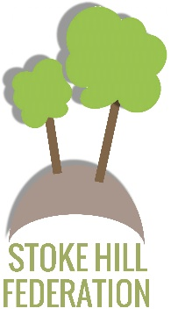

Year 1 Learning Letter – Autumn 2021