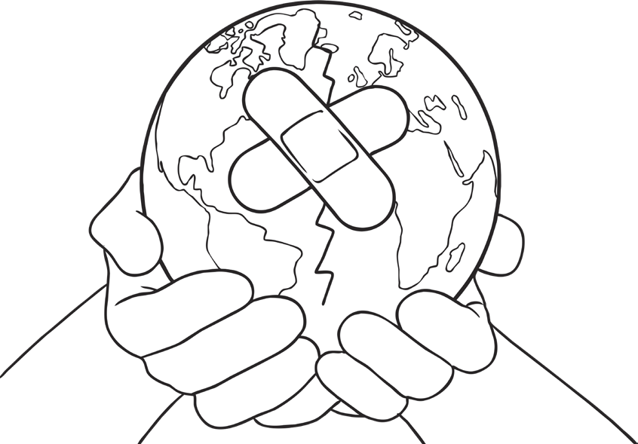
My Guide to Save the Planet Think of 5 TOP TIPS to help save our wonderful world. Remember, lots of small changes all add up to make big changes. Draw 5 pictures and write instructions for each one. Try and use those bossy verbs!

