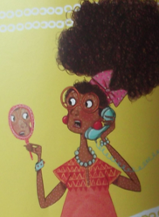 | One hot morning Auntie Rosie woke up covered in spots.
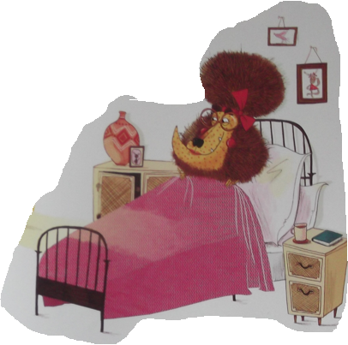 | When Little Red arrived, she knew it wasn’t her auntie and she decided to teach the lion a lesson.
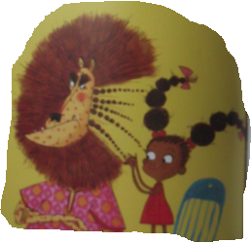 | Little Red brushed and combed until the lion had a lovely new look.
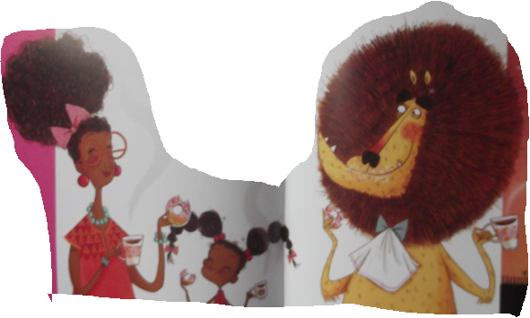 | The lion let Auntie Rosie out of the cupboard and they munched through a basketful of doughnuts together.
Comic Strip Ideas

