Year 2 Measuring capacity
Read a scale counting in 100ml and draw an accurate measurement onto a 1 litre measuring jug. Draw the following amounts onto the blank measuring jug. Remember to use a ruler to draw a straight line, and then colour the jug to show that amount of liquid and write the amount. The first one has been done for you.
200ml 400ml 300ml
600ml 900ml 1000ml
150ml 250ml 850ml

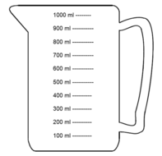
200ml

If you would like an extra challenge, you could try some of the extra capacity sheets on the BBC Bitesize link, Measuring in millilitres on the Year 2 webpage. website>learning at home>Year 2>maths Or you could follow the link to the ‘Reading scales quiz’ to see how much you can remember.

