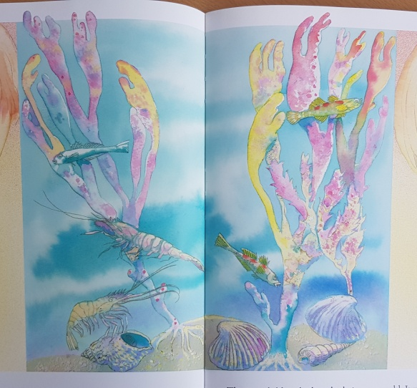
One World: Rockpool world
Watch the story video ‘One World’ and watch the BBC bitesize clip ‘What’s in a rock pool? ’. Create your own rock pool world in the bucket below, like the children in the story did. Use beautiful colours like the illustrations in the book and include the creatures and plants you might find in a rockpool.
