What we do… | Charitable Status | Charity Number
Our motto is ‘We are all the PTFA’ to dismiss the myth that this is a club – EVERYONE is encouraged to have take part in the activities we plan to support the school and to raise funds.  Welcome to you all. | - We are a charity  - Your employer might donate as part of their community involvement. | Charity Number: to be added here  https://www.parentkind.org.uk/Info-sheets/Matched-Giving
How you could help | PTFA Events | Matched Funding
- Ask your Human Resources Department or Line Manager whether they support charities through matched funding.  - Visit the school website and download this form to help you: Add in letter link | Christmas Fair  Fireworks Evening  Summer Fair  All these events raise money for our school and if your employer could match the funding that we raise this could give the school £1000s to support the school and our children. | How could your employer help?  - Matched funding of an event  - Donation of equipment  - Donation of services  - Donation of prizes
Other useful Funding Opportunities
- Volunteering days – Ask at your company if they might be able to help us.
- Supporting events – Might you know people at work or at an organisation who can help.
- Donating – Your place of work might be able to donate a raffle prize for one of our events.

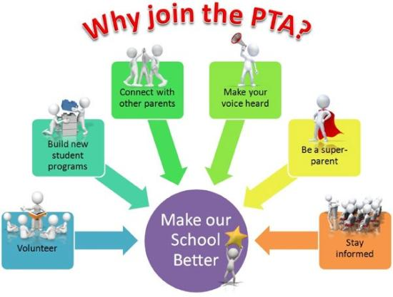 | please feel free to e-mail:  infantschoolPTFA@stokehill.devon.sch.uk  with any suggestions or volunteering with any of our fund-raising events  Address:  Stoke Hill Infant and Nursery School,  Stoke Hill, EXETER  EX4 7DB  Phone:  Infant and Nursery  01392 258894  Website:  www.stokehill.devon.sch.uk  Twitter  @Stokefed | Stoke Hill Federation  Nursery & Infants  PTFA  “We are all the PTFA” – get involved!  FUNDING LEAFLET  Inspire – Discover - Succeed

