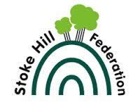

2016-2017 End of Key Stage 2 National Tests

Reading

Attained Standard |  | Exceeded Standard
School | 80% | School | 31%
National | 75% | National | 25%

Maths

Attained Standard |  | Exceeded Standard
School | 85% | School | 24%
National | 76% | National | 23%

Writing

Attained Standard |  | Exceeded Standard
School | 82% | School | 16%
National | 78% | National | 18%

Grammar, Punctuation and Spelling

Attained Standard |  | Exceeded Standard
School | 80% | School | 33%
National | 78% | National | 31%

Average Scaled Scores

 | School | National
Reading | 106.1 | 104
GPS | 106.2 | 106
Maths | 105 | 104

Combined reading, writing and maths for the school was 73%.
Combined reading, writing and maths nationally was 64%.

