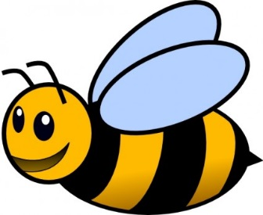
Buzzy bees
- There were 19 bees sitting in their hive. 5 flew away to get some pollen. How many bees were left in the hive?

- One day, 52 bees were buzzing in a garden. 12 flew home suddenly. How many bees were left in the garden?

- There are 47 bees in a colony. 44 are males. How many are females?

- The sun was shining and 76 bees were trying to get pollen from a flower. 23 bees gave up and went elsewhere. How many bees were still at the flower?

- There were 63 bees sleeping in their hive. 21 woke up. How many bees were still asleep?

- There were 125 flowers in a meadow. A lawnmower accidently cut down 13! How many flowers were left?

- There were 58 drones in a colony and 25 got sent on a mission. How many drones were left at home?

- Out of 88 larvae in a colony, only 35 hatched into bees. How many larvae did not hatch?

- The bees make 132 jars of honey in a year. The farmer is left with 28 jars in the shop. How many jars has he sold?

Now try writing some bee problems for someone in your family to solve.

