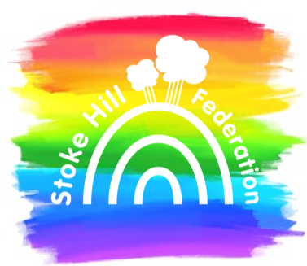
Stoke Hill Junior School

Update 6.11.20

Governors
Hi, we’re Amy and Tom and we are the new co-chairs of the Governors for the Stoke Hill Federation. Amy has children in Nursery and Year 3. She has worked with children and young people for over 25 years and believes strongly that all children deserve an inspiring and joyful education.

Tom has two children, one in the Juniors and one in the Infants. He is a barrister at Magdalen Chambers where he specialises in family law. He wants all the children at Stoke Hill to be inspired to achieve their best and have a stimulating and rewarding time at school.

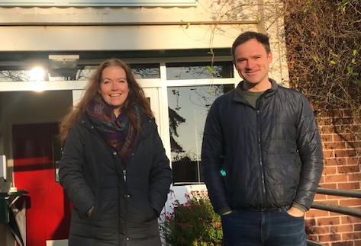
The role of the governors is to act as a critical friend towards the school; providing both support and challenge to ensure that resources are managed effectively and that the best possible outcomes for children are achieved. We are really looking forward to working with the school community to help achieve these objectives.

You will see one or both of us at school most days, so if you have any questions about governance (or if you think it’s something you might like to do yourself!) then please do stop us to say hello.

Coronavirus
We will be continuing with our current control measures for the foreseeable future:

- Staggered start and end times of the school day
- Staggered break and lunch times
- Lots of extra handwashing
- Children only using their own stationery and equipment in class
- Keeping the windows and doors open
- Asking you to keep your child off school if they show any coronavirus symptoms, or if they have been in contact with someone who has

Government guidance on face coverings in primary schools has not changed. It says ‘Based on current evidence and the measures that schools are already putting in place, such as the system of controls and consistent bubbles, face coverings will not be necessary in the classroom even where social distancing is not possible. Face coverings could have a negative impact on teaching and their use in the classroom should be avoided.’

The children can, however, wear masks on their way into and out of the school building and as they move through the corridors if you would like them to.

Only essential visitors are allowed in school, and we ask them to wear masks at all times. We now also strongly encourage you to wear a mask if you come on to the school grounds to drop your child off or pick them up at the end of the day, especially if it is difficult to keep two metres away from other people.

It seems strange to say this, but please don’t get your child to school too early – if they are in Y3 or Y5 they need to get here between 8.30am and 8.40am. If they are in Y4 or Y6 they need to get here between 8.40am and 8.50am. I know there are some issues with dropping off siblings, but other than that please make sure your child gets here at the right time. If children from different year groups mix on site, we may have to send more children home in the event of an outbreak.

Children in Need
Next Friday is Children in Need. If your child wants to, in return for a donation they can wear something spotty or stripy to school instead of their school uniform. In response from a heartfelt request from some of our Y6 children, I can clarify that this means they don’t have to wear any of their uniform! Please do not bring cash to school. If you would like to make a donation, you can do so by visiting https://donate.bbcchildreninneed.co.uk.

Accelerated Reader
The children have been working really hard with their reading. It’s lovely chatting to them about books and stories, and to see them developing a real love for books.

We have looked through our Accelerated Reader records for October, and would like to celebrate the fact that between them the children read over 2200 books between them! The top classes in each year group for October were:

Year 3 3G – 295 books and 748,589 words
Year 4 4LP – 260 books, 3.3 million words
Year 5 5HM – 96 books, 2.5 million words
Year 6 6AE – 122 books, 4.8 million words

Well done everyone!

Have a good weekend ~ Roy Souter

