Stoke Hill Infant and Nursery School

Update 21.5.21

A message from our new Executive Headteacher Mrs. Yvonne Hammerton-Jackson

Dear Families and Staff of Stoke Hill,
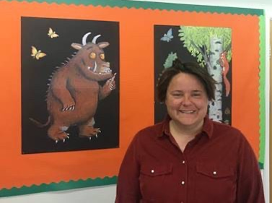
I thought I would take the opportunity to briefly introduce myself before the summer holidays and before I officially start in my new role of Executive Head of Stoke Hill Federation in September.

At the time the Stoke Hill Federation was formed in 2011, I was starting my first Headship in West Berkshire and since then I have gone on to lead two other Primary Schools. I aim to bring my well-rounded experience of Headship to Stoke Hill and build on the strong foundations that are clearly already in place.

The move towards an Executive Head leadership structure does mean there will be some changes but I believe that change is a process not an event, and that any change should be considered, transparent and inclusive.

The interview days seem like a life time ago and I am looking forward to next week when I will see you all in person once again and start the process of really getting to know Stoke Hill.

Lastly, just a final note to say that although I have been away for many years, Devon is very much my home. I grew up in Bampton, went to school in Tiverton and my family are still local. I have also been a season ticket holder for the Exeter Chiefs for many years and I am looking forward to a season when the home games are closer than the away ones!

Yvonne Hammerton-Jackson

We are all really looking forward to getting to know Mrs. Hammerton-Jackson and working with her to make sure everything is ready for the start of next school year. She will be joining us on Monday, Tuesday and Wednesday next week, taking part in the recruitment process for the new SENCO, and starting to get to know about our wonderful school community.

With kind regards for the weekend ahead, Sarah Mackay Head Teacher

