 | Year 2 Knowledge Organiser – Karibo to Africa, Jumbo!
 | Subjects: Science & Geography |  |  | Term: Autumn 2nd half term 2021
National Curriculum |  | Vocabulary | Definitions | Research Opportunities
In science and geography we will..  - name and locate the world’s 7 continents and 5 oceans  - locate hot and cold areas of the world in relation to the Equator and the North and South Poles.  - identify that most living things live in habitats to which they are suited and describe how different habitats provide for the basic needs of different kinds of animals  - investigate woodlice habitats around school, and collect data. |  | habitat | the natural home or environment of an animal or plant | Go and visit the local museum!  Go and visit the Royal Albert Museum on Queen Street and explore. Be sure to find the animal section and see how many animals you can find that came from Africa.  Why not take a sketchbook and some pencils and try to draw as many different ones as you can.  Choose one animal and find out 5 fascinating facts about them and then make your own mini fact file. We would love to see what you make!
 |  | food chains | a series of plants and animals each dependent on another as a source of food
 |  | producer | green plants produce their food by taking sunlight and using the energy to make sugar.
 |  | consumer | living things that need to eat to obtain energy
 |  | adaption | how animals adapt to be able to survive in their environment.
Stoke Hill Characteristics |  | 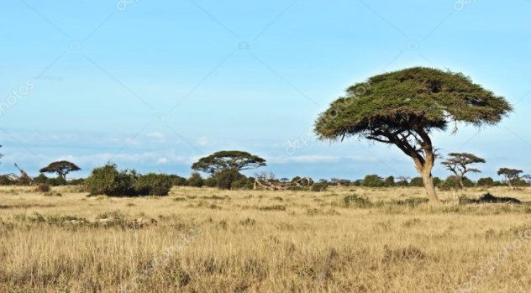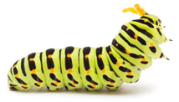  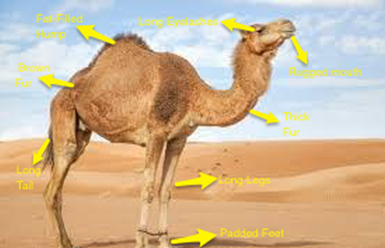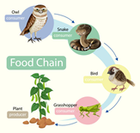 |  | Year 2 are also interested in…
Critical thinking  How many African animals can you name?  How have they adapted to suit their environment?  Are they predators or prey or both?  What is the collective noun for them? E.g. A pride of lions. |  |  |  | Plants !  Why don’t you plant some bulbs then observe and describe how seeds and bulbs grow into mature plants.  You could find out and describe how plants need water, light and a suitable temperature to grow and stay healthy.

