My new class
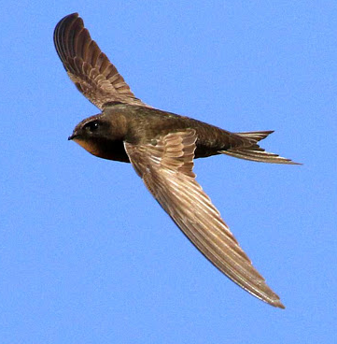  Swift | 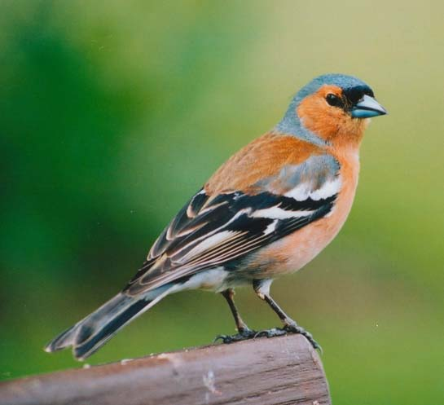  Chaffinch | 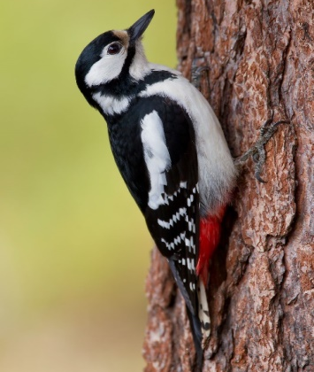  Woodpecker
Did you find your new classroom on the map? Can you remember the name of your new class? Do you know what your class bird looks like?

Make a careful drawing of your class bird. Look at the shapes and colours of the beak, the wings and the body. Add some sentences to say what you are looking forward to in September.

In Year 2 I am looking forward to ______________________________
____________________________________________________________________________________________________________________

