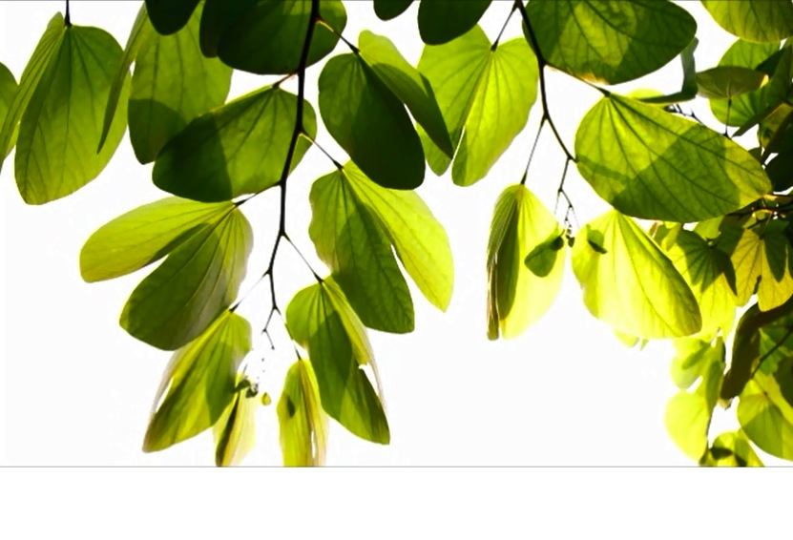**Year 2 Learning Letter**

**Year 2**

**Autumn Home Learning**

**ESSENTIAL each week:**

**Reading**

X3 sessions of up to 15 minutes per week.Make a time to read regularly. Little and often is best but as the complexity and length of book increases more time might be needed. Priority should be given to the Guided Reading text, which we expect you to read three times at home with your child. Always have a conversation about what you have read and understand.

**Maths**

x3 sessions of up to 15 minutes practise of the current maths skills on Education City**.** New homework tasks will be updated fortnightly.

If you misplace your child’s login details, please ask for a reminder*.*

**OPTIONAL to enjoy over the Autumn Term** *to further support your child’s learning and skills. How much time to spend on each task will depend on the activity. A good rule to go by is… enough time to enjoy but not too much time to make learning a chore.*

**Research:** What do you know about the seven wonders of the world? How many are in each of our seven continents?

**Go:** Can you visit the Royal Albert Memorial Museum in Exeter to see how many African animals you can spot?

**Draw or make:**  Can you draw a picture of your favourite place to go on a journey to?

This Half Term’s Project ‘**Karibu to Africa, Jumbo!’**

Our new project for this half term is called ‘Karibu to Africa, Jumbo!’, meaning ‘Welcome to Africa, Hello!’ which is filled with lots of exciting activities. In Geography, the children will be learning to locate the seven continents and five oceans of our world, shown the equator and taught how this helps us to identify hot and cold countries on a map. During our science lessons, the children will explore how to sort a range of animals based on the habitats they live in, looking at how their bodies are suited to the different environments, like the desert, jungle, ocean or savannah. In Art and DT, we will explore different animal markings and camouflage to learn how this helps animals survive, before making individual tie-dyed fabric squares to use on our Christmas cards. We are also really looking forward to visiting the Phoenix as our Christmas treat this year, to watch a theatre performance of Rhia and the Tree of Light!

**Knowledge Organiser** You will find attached to this document what we are calling a ‘Knowledge Organizer’. This captures the knowledge and vocabulary we are focusing upon in an area/s of the curriculum. Do take some time to look this through so that you can help your child to remember the things they are learning in science and geography.

English

Our first English unit this term is centred around a story called ‘Don’t Spill the Milk’. This journey text will support the children with producing their own journey story and punctuating this with full stops or exclamation marks. There will also be a focus on the inclusion of prepositions, such as ‘under’, ‘past’, ‘between’, and prepositional phrases such as ‘up in the grasslands’ or ‘across the river’. Towards the end of the term, we will be looking at a selection of seasonal winter poems and having a go at writing our own.

Mathematics

This term in Maths, we will continue to develop our number skills through addition and subtraction, as well as begin to explore new strategies in multiplication and division work. As well as this, we will begin a unit of work centred about measures, including a focus on weight, capacity and length. These will include both practical activities and the development of mental maths, in both individual, paired and group contexts.

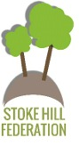

*‘If parents want to give their children a gift the best thing they can do is to teach their children to love challenges, be intrigued by mistakes, enjoy effort and keep on learning. That way, their children don’t have to be slaves of praise. They will have a lifelong way to build and repair their own confidence.* ***Carol Dweck***

Year 2 Learning Letter – Autumn 2021