Stoke Hill Junior School

Update 25.9.20

Possible Lockdown Plans
If your child is asked to isolate for a Covid-related reason we will send home a pack of learning activities for them to complete. This will be linked to the work the rest of the class is doing, and will be marked by their teacher on their return to school. This is an interim solution, and we are continuing to work on a more comprehensive system that will allow any child who is well and not in school to receive the best possible education while they are at home.

If we have to go through a further lockdown we will be making use of an online learning platform to make sure all of the children have access to their teacher and are able to take a full part in all planned activities.

Over the next few weeks we will be making sure all the children know how to use the learning platform, and are preparing resources that will help you understand it as well.

To make sure this can work, all children will need to have access to an appropriate computer at home. We are very lucky to have received an extremely generous donation from Rx-info, allowing us to purchase extra Chromebook computers to lend to children who do not have their own. Their representative said, ‘As an Exeter business we are pleased to be able to support the young people and teaching staff of Stoke Hill Junior School. Modern technology provides us with the best possible opportunity to normalise a difficult situation’.

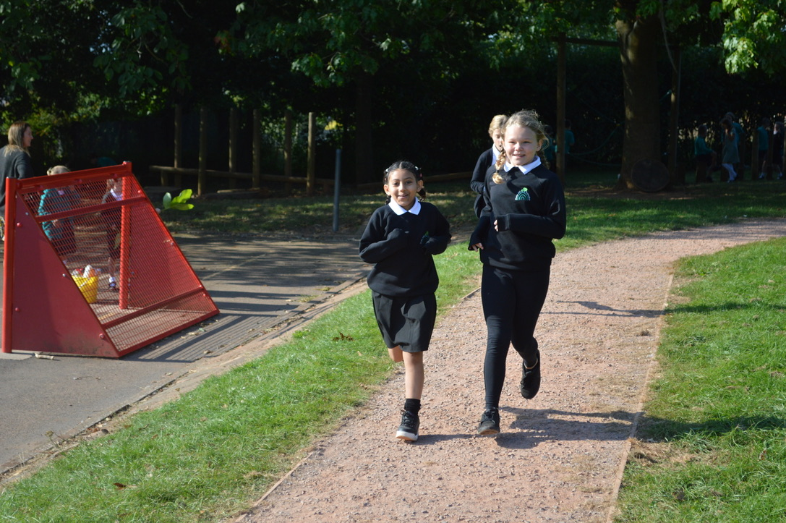
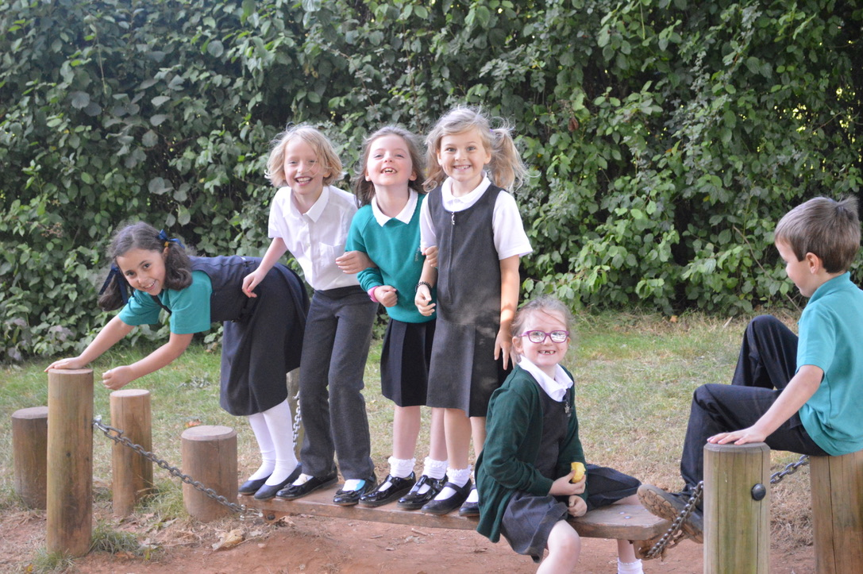
We need to create a register of who may need these so that we can get them to you quickly if we need to. Please could you therefore return the attached slip to let us know that if your child has to stay at home for a Covid-related reason you would like to borrow a Chromebook for your child. There will be no cost for this, and you will be able to keep them at home as long as needed.

Coats
We have been enjoying the lovely weather over the last few weeks, so it has been a bit of a shock to see the rain and to feel a bit of an autumn chill on Wednesday and Thursday! We will continue to try and spend all of our break and lunchtimes outside, so please make sure your child brings their coat every day. It’s also a good idea to make sure coats and jumpers are named, as they can be abandoned and forgotten about when the sun starts shining.

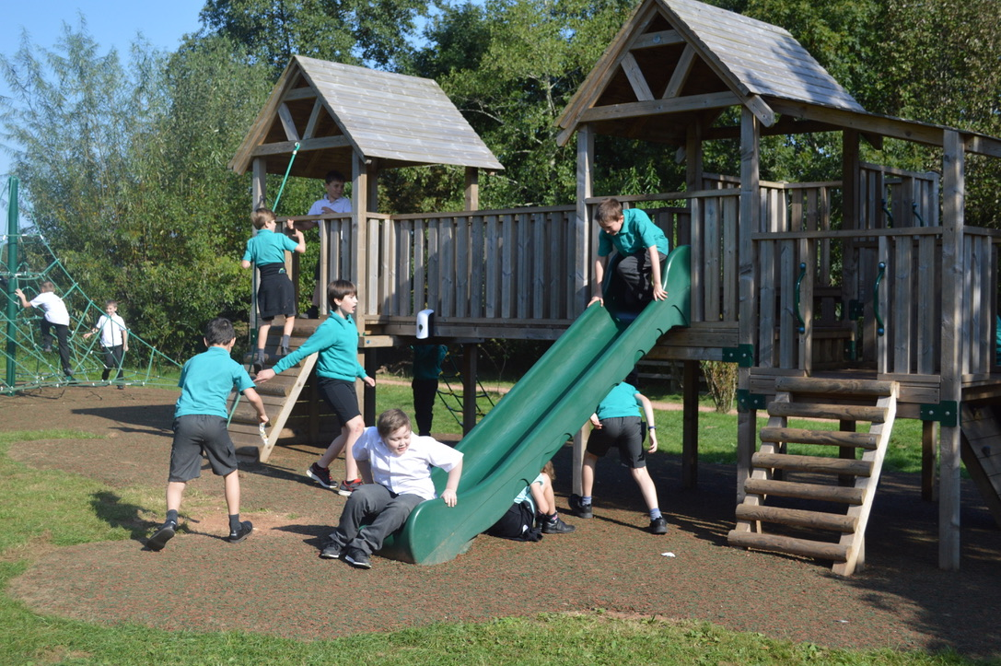
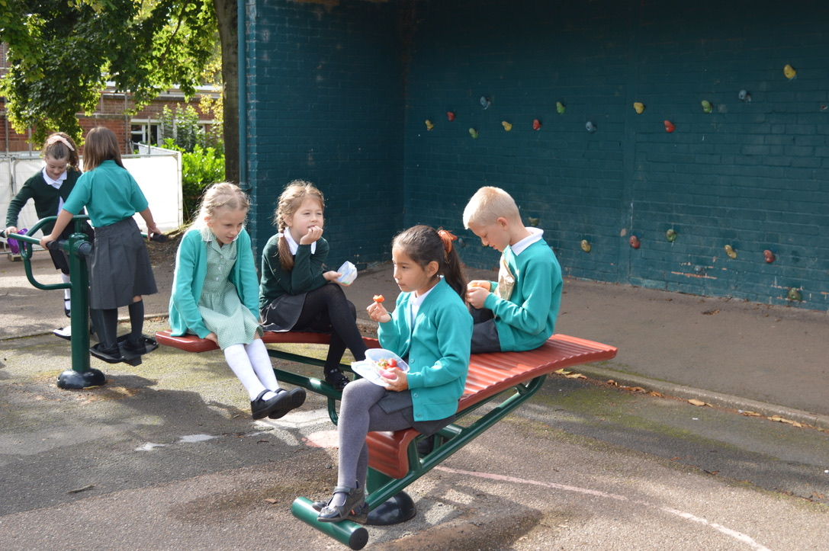
Even when the weather cools we will be continuing to keep classroom windows and doors open to increase ventilation. We will turn the heating up to compensate, but on colder days an extra layer will keep the children more comfortable.

Meet the Teacher
You will see an email in the next few days inviting you to book a slot to have a conversation with your child’s teacher. On this occasion this will be over the phone, as it is the quickest and simplest way for us to reach as many of you as we can. Please look out for the message. If you are stuck with the online booking system please call Andrea in the office (01392 667830) and she will help you.

Have a good weekend

Roy Souter

………………………………………………………………………………………………………………………………………………

Please return this form to Mrs Prunty in the School Office:

Child’s name……………………………………………. Class……………………….

I would like to borrow a computer if my child needs to self-isolate due to Covid-19, or if there is another lockdown.

Signed……………………………………………………… Name……………………………………………….

