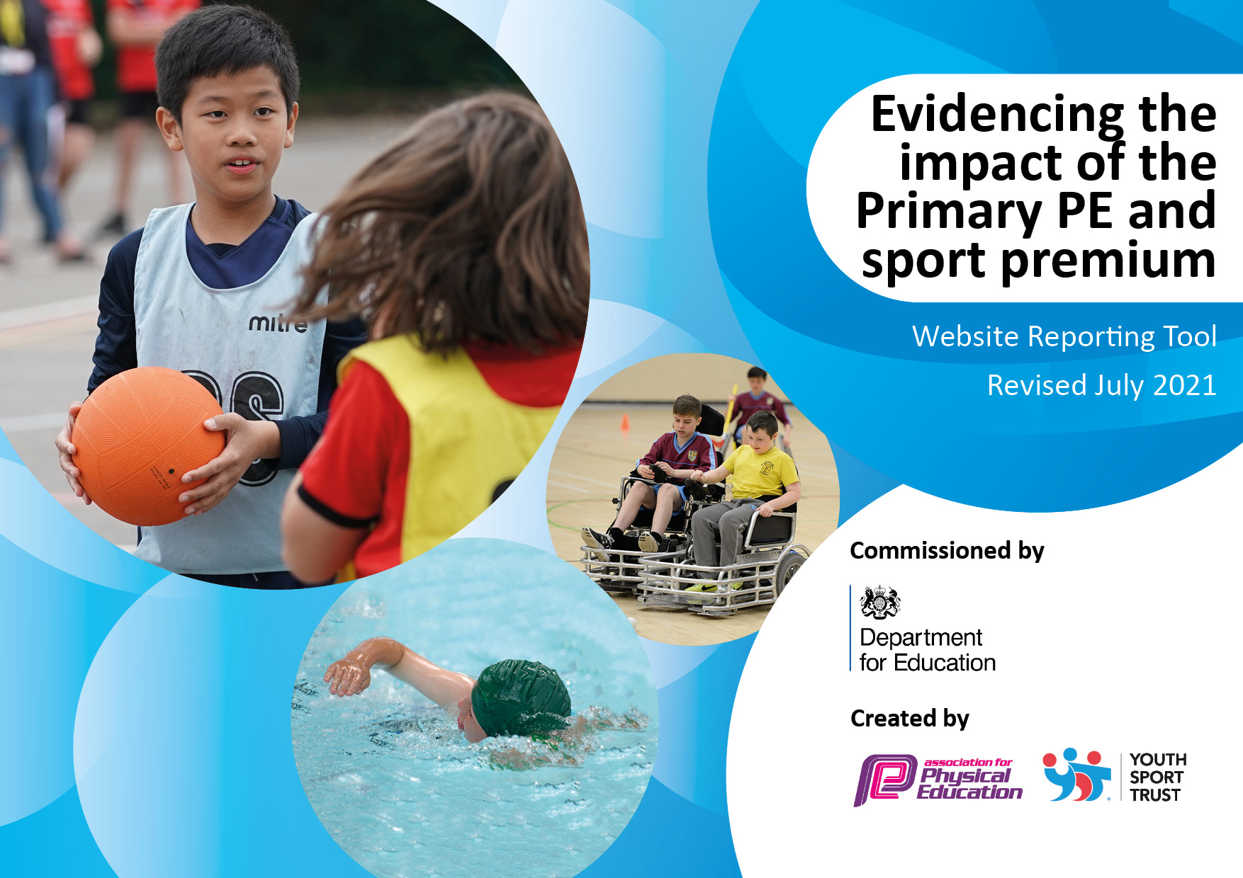

It is important that your grant is used effectively and based on school need. The Education Inspection Framework makes clear there will be a focus on ‘whether leaders and those responsible for governors all understand their respective roles and perform these in a way that enhances the effectiveness of the school’.

Under the Quality of Education Ofsted inspectors consider:
Intent - Curriculum design, coverage and appropriateness
Implementation - Curriculum delivery, Teaching (pedagogy) and Assessment
Impact - Attainment and progress

To assist schools with common transferable language this template has been developed to utilise the same three headings which should make your plans easily transferable between working documents.

Schools must use the funding to make additional and sustainable improvements to the quality of Physical Education, School Sport and Physical Activity (PESSPA) they offer. This means that you should use the Primary PE and sport premium to:

- Develop or add to the PESSPA activities that your school already offer
- Build capacity and capability within the school to ensure that improvements made now will benefit pupils joining the school in future years
- The Primary PE and sport premium should not be used to fund capital spend projects; the school’s budget should fund these.

Pleasevisitgov.ukfortherevisedDfEguidanceincludingthe5keyindicatorsacrosswhichschoolsshoulddemonstrate animprovement.Thisdocumentwillhelpyoutoreviewyourprovisionandtoreportyourspend.DfEencouragesschools to use this template as an effective way of meeting the reporting requirements of the Primary PE and sport premium.

We recommend you start by reflecting on the impact of current provision and reviewing the previous spend.

Schools are required to publish details of how they spend this funding, including any under-spend from 2019/2020, as well as on the impact it has on pupils’ PE and sport participation and attainment. All funding must be spent by 31st July 2022.

We recommend regularly updating the table and publishing it on your website throughout the year. This evidences your ongoing self-evaluation of how you are using the funding to secure maximum, sustainable impact. Final copy must be posted on your website by the end of the academic year and no later than the 31st July 2021. To see an example of how to complete the table please click HERE.

Details with regard to funding
Please complete the table below.

Total amount carried over from 2020/21 | £1863
Total amount allocated for 2021/22 | £19574
How much (if any) do you intend to carry over from this total fund into 2022/23? | £0
Total amount allocated for 2021/22 | £21437
Total amount of funding for 2021/22. To be spent and reported on by 31st July 2022. | £21437

Action Plan and Budget Tracking
Capture your intended annual spend against the 5 key indicators. Clarify the success criteria and evidence of impact that you intend to measure to evaluate for pupils today and for the future.

Academic Year: 2020/21 | Total fund allocated: | Date Updated:
Key indicator 1: The engagement of all pupils in regular physical activity – Chief Medical Officers guidelines recommend that primary school pupils undertake at least 30 minutes of physical activity a day in school |  |  |  | Percentage of total allocation:
 |  |  |  | 26%
Intent | Implementation |  | Impact
Your school focus should be clear what you want the pupils to know and be able to do and about  what they need to learn and to  consolidate through practice: | Make sure your actions to achieve are linked to your intentions: | Funding allocated: | Evidence of impact: what do pupils now know and what can they now do? What has changed?: | Sustainability and suggested next steps:
All children to complete Couch to 10K  Build a weekly programme of activities that all children can take part in. | - During the Autumn Term use the Daily Mile track to begin Couch to 10K for all children  - Resurface Daily Mile Track  - Timetable of indoor and outdoor activities to allow physical activity to happen daily in class | £500  £5000 | - Children winning medals for their achievement  - Positive attitudes towards running developing  - All children have access to high quality activities daily
Key indicator 2: The profile of PESSPA being raised across the school as a tool for whole school improvement |  |  |  | Percentage of total allocation:
 |  |  |  | 56%
Intent | Implementation |  | Impact
Your school focus should be clear what you want the pupils to know and be able to do and about  what they need to learn and to  consolidate through practice: | Make sure your actions to achieve are linked to your intentions: | Funding allocated: | Evidence of impact: what do pupils now know and what can they now do? What has changed?: | Sustainability and suggested next steps:
MTA’s engage children in structured physical activity.  Profile is raised through children identifying with positive sporting role models  Improved links with other Primary and High Schools  Use of media to publicise achievement | - Train MTA’s in leading games  - Use of Premier Sports to lead games at lunchtimes  - Appoint TLR3  - Sporting Ambassadors established  - Displays and assemblies on positive role models  - Competitions or tournaments set up half termly across year groups in school | £5712  £3430  £2400  £500 | - All children to have access to adults leading games at lunchtimes.  - Positive attitudes towards sport, winning and losing

Key indicator 3: Increased confidence, knowledge and skills of all staff in teaching PE and sport |  |  |  | Percentage of total allocation:
 |  |  |  | 4%
Intent | Implementation |  | Impact
Your school focus should be clear | Make sure your actions to | Funding | Evidence of impact: what do | Sustainability and suggested
what you want the pupils to know | achieve are linked to your | allocated: | pupils now know and what | next steps:
and be able to do and about | intentions: |  | can they now do? What has
what they need to learn and to |  |  | changed?:
consolidate through practice:
Ensure all teachers have an up to date knowledge of the sports they are teaching.  High quality resources available to improve the PE provision. | - Review the current provision to establish any training needs.  - Purchasing a new online scheme to support teachers  - Update current resources and purchase anything for new sports | £895 | - Teachers are confident and highly skilled in teaching a range of existing and new sports.  - Children’s skill levels improve  - Teachers and children will have high quality resources to use.
Key indicator 4: Broader experience of a range of sports and activities offered to all pupils |  |  |  | Percentage of total allocation:
 |  |  |  | 5%
Intent | Implementation |  | Impact
Your school focus should be clear | Make sure your actions to | Funding | Evidence of impact: what do | Sustainability and suggested
what you want the pupils to know | achieve are linked to your | allocated: | pupils now know and what | next steps:
and be able to do and about | intentions: |  | can they now do? What has
what they need to learn and to |  |  | changed?:
consolidate through practice:
Children are able to participate in a range of sports not just traditional school ones.  More children meet the national curriculum swimming targets | - Establish links with local clubs for children to try new sports.  - Purchase resources to allow for participation in new sports.  - Review current swimming provision and seek funding opportunities | £1000 | - All children to experience at least 2 new sports during the school year.  - 75% of year 6 children are able to swim 25m by the end of key stage 2.

Key indicator 5: Increased participation in competitive sport |  |  |  | Percentage of total allocation:
 |  |  |  | 10%
Intent | Implementation |  | Impact
Your school focus should be clear | Make sure your actions to | Funding | Evidence of impact: what do | Sustainability and suggested
what you want the pupils to know | achieve are linked to your | allocated: | pupils now know and what | next steps:
and be able to do and about | intentions: |  | can they now do? What has
what they need to learn and to |  |  | changed?:
consolidate through practice:
All children take part in competitive sport during the school year. Focus on disadvantaged children being given opportunities of representing teams. | - Re-structure Sports Day to allow all children to compete in competitive sport.  - Organise half termly inter class competitions  - Sign up to School Games to enhance opportunities for new sports and for children to learn about competition | £1000  £1000 | - More children taking part in competitive sport internally and externally.  - Established links with other schools and a calendar of regular competitions established

Signed off by
Head Teacher:
Date:
Subject Leader:
Date:
Governor:
Date:

