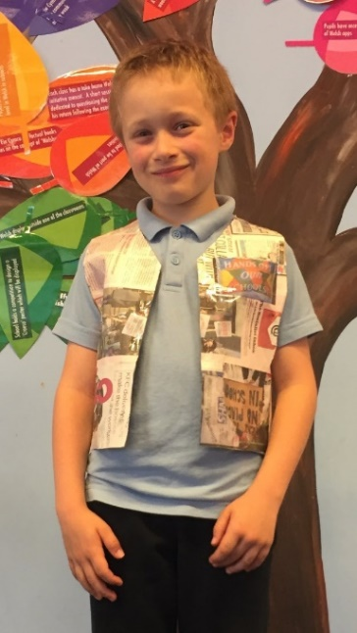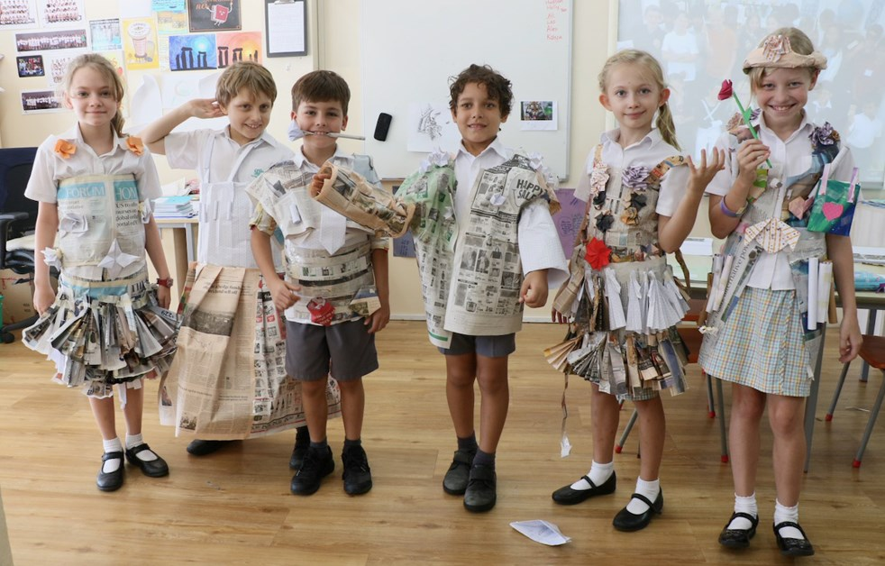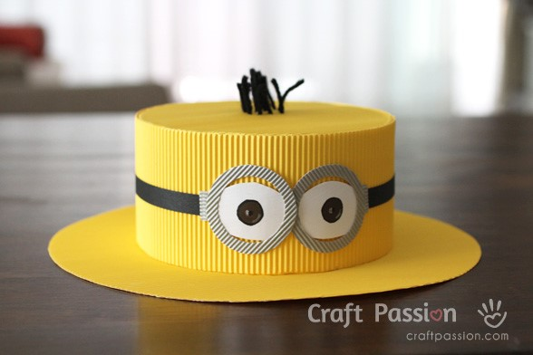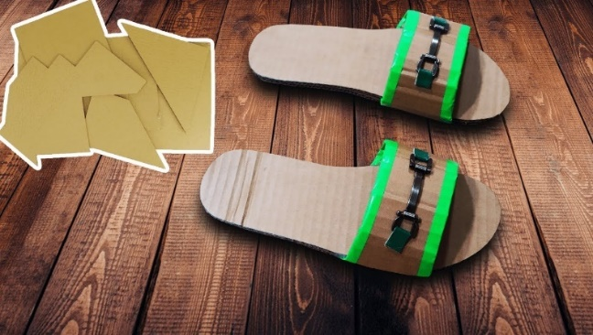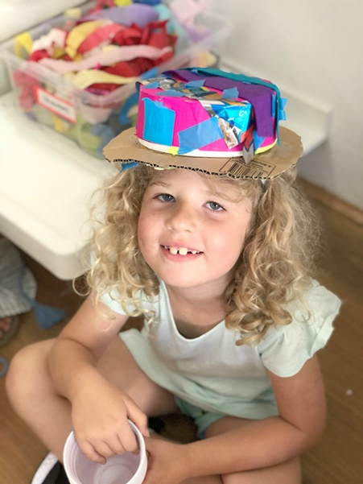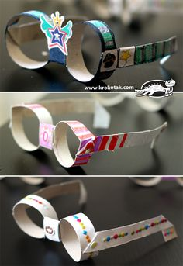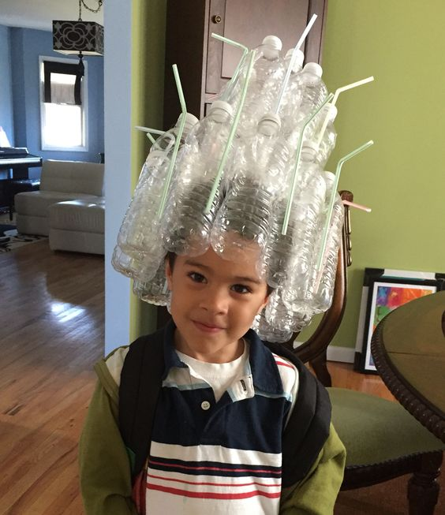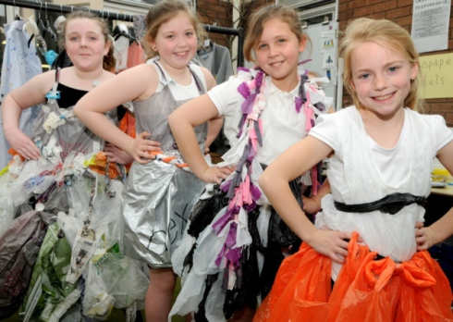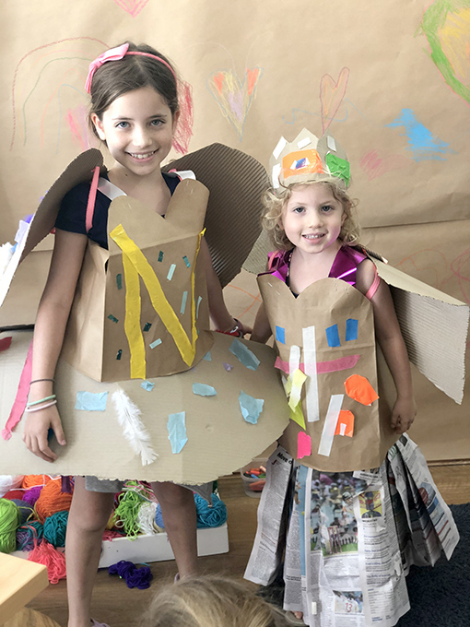

**Can you design an item of clothing from the materials in your recycling box?**

Have a look at what you have in your recycling bin. Are there any cardboard boxes, plastic bottles, tubes, straws etc? What could you use to make a sun hat, some sunglasses, a pair of flip flops?

Here are some ideas to get you started!

Use the design sheet to design your item of clothing, thinking about what you will need, and then have a go at making it, you may need an adult to help you.

You can be as creative and imaginative as you like! You could even try and make a whole outfit!

We would love to see some photos of you final creations!