**Design a poster to Save our Oceans**

Look at the PowerPoint **All about plastic pollution** website>Learning at Home>Year 1. Draw a poster to encourage people to look after our oceans. **What important messages** do you want your poster to tell people?

What **small changes** can we all make that will add up to one **big change**?

Here are some picture ideas to get you started and some useful words.

You can use the sheet on the next page or a blank piece of paper.



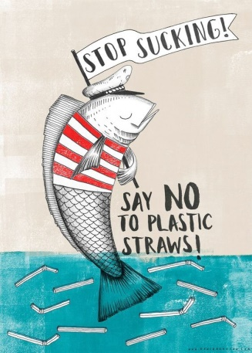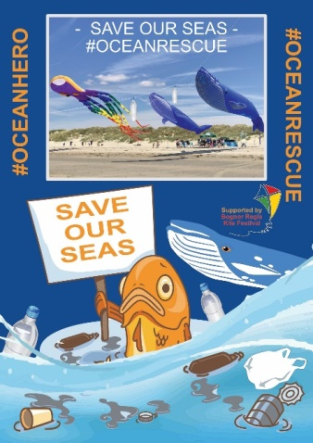

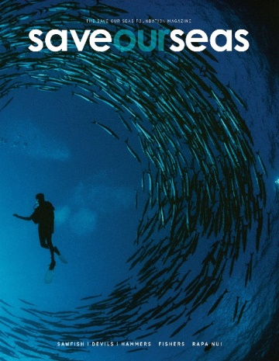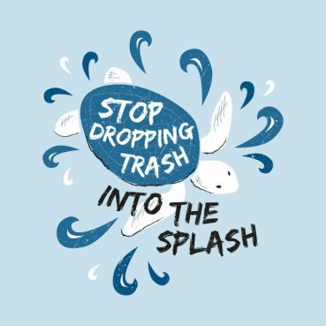

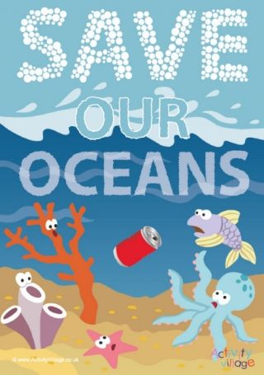

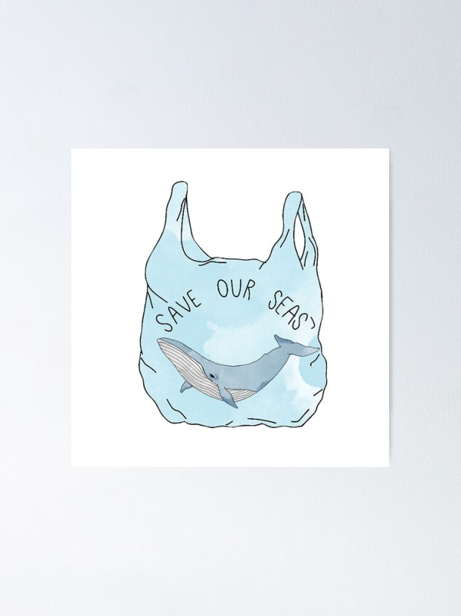

If this learning has really inspired you visit the website>Learning at Home>Year 1 to find more links to videos and PowerPoints about looking after our oceans.

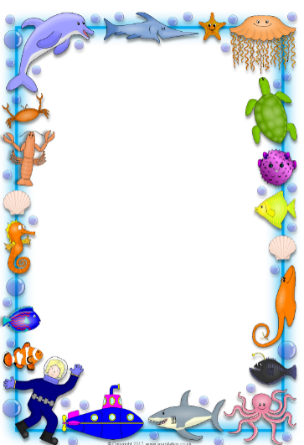**Save our Oceans poster**