**Little Red and the Very Hungry Lion**

**Story Map**

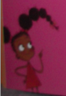

Sorry

