Stoke Hill Junior School

Update 8.1.21

Welcome back
I hope you all had a restful break – it’s been a very challenging start to the new year, but hopefully 2021 will prove to be a good one for all of us.

It has been lovely to see the children who are here in person, and to see the children who are home connecting with their teacher and classmates remotely. We will keep finding ways to make sure our school community stays together over the coming weeks and months.

The children have, as always, been brilliant. They have adapted to the new situation, and are getting on with learning, playing and just being children.

We have had lots of supportive messages from you. Thank you for every one – they really do make a difference.
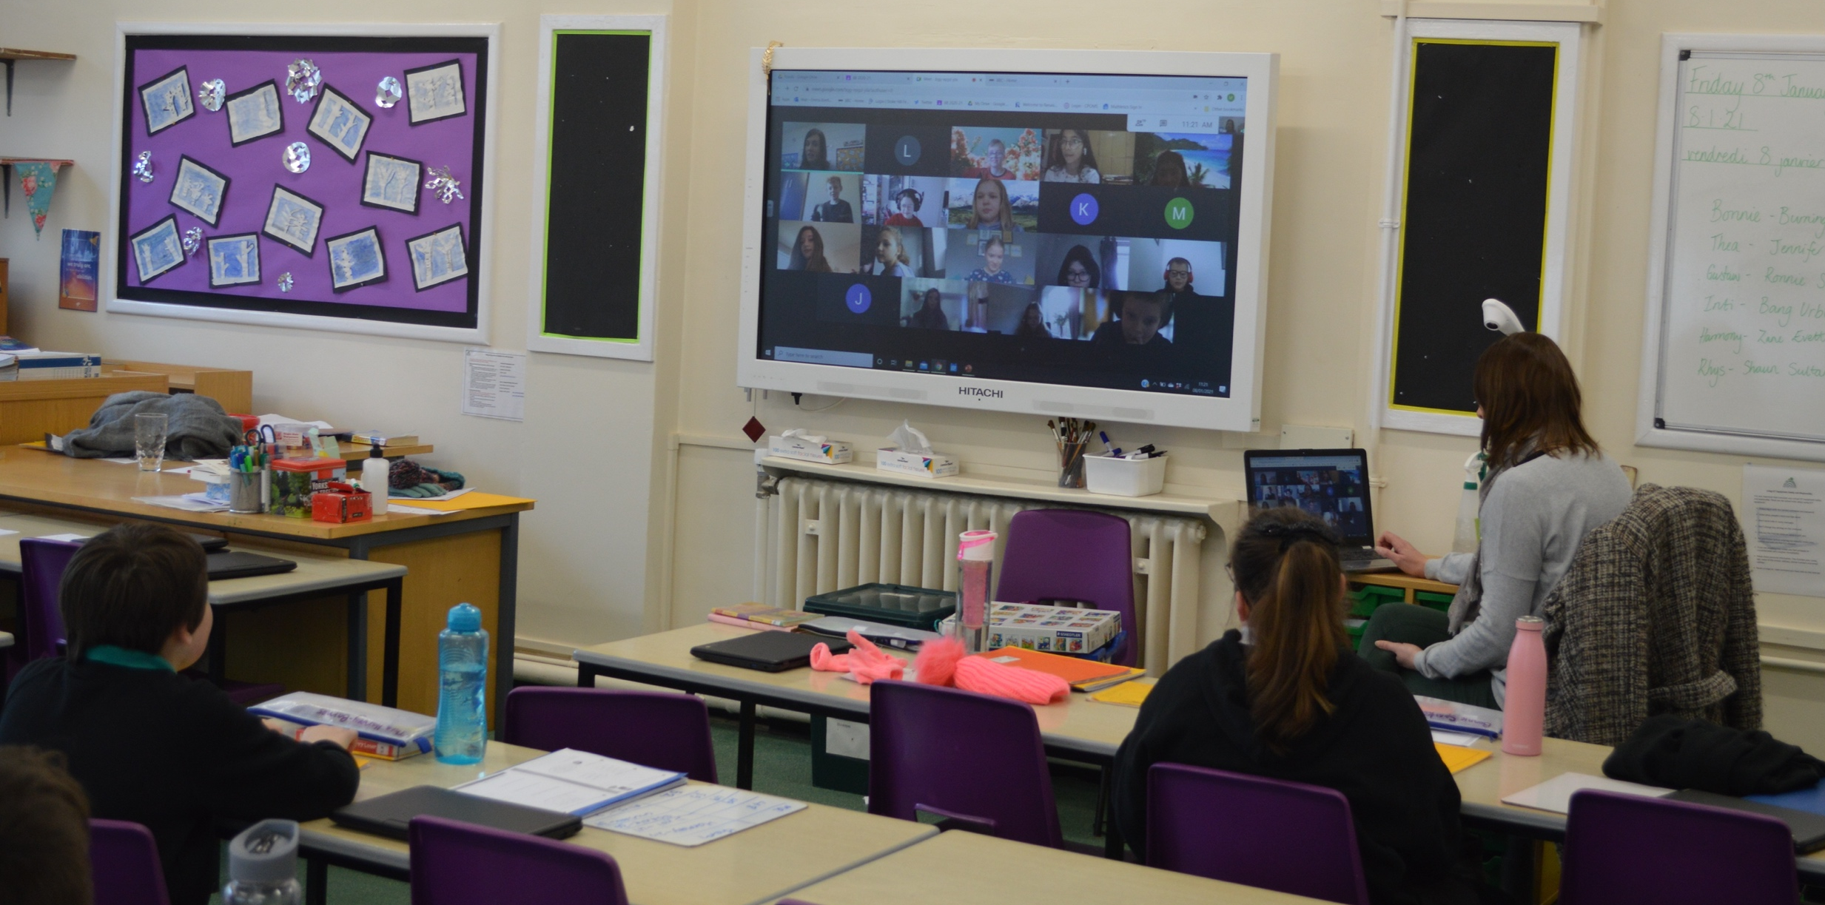

Attendance at school and online learning
The children who are learning at home are being set the same tasks as the children who are in school. We expect the children who are at home to try and engage as much as they can with their work, and to make use of the Google Meet sessions and the ongoing text facility in Google Classroom to ask for help if they are stuck.

To keep everyone as safe as possible, we would ask you to think carefully about whether or not your child needs to be in school, even if they are entitled to a place. The guidance says ‘Parents and carers who are critical workers should keep their children at home if they can’.

Having fewer children in classrooms means that those who are learning at home can have more ‘teacher time’, as well as allowing us to keep the children who are here further apart and minimising the risk of passing the virus around.

It may be the case that your child is entitled to be in school, but you only need them to be here on some days. We are more than happy to support you in this. Please let us know if this is the case for you, and what days you need your child to be here. If your child is at school on some days they will still need to complete their learning tasks on the days they are at home.

The full government guidance, including details of the measures that are in place to keep schools as safe as possible, can be found here:

https://assets.publishing.service.gov.uk/government/uploads/system/uploads/attachment_data/file/950510/School_national_restrictions_guidance.pdf

Online learning
The government has set up a scheme that temporarily increases data allowances for mobile phone users on certain networks. This is so that children and young people can access remote education if their face-to-face education is disrupted.
If you would like to take advantage of the scheme you will need to send the following information to junior.admin@stokehill.devon.sch.uk
- the name of the account holder
- the number of the mobile device
- the mobile network of that device (for example Three)
If you do so by next Friday (15th January) we will then submit the request to the gov.uk website.
We have also applied for a number of 4G routers, which allow you to access the internet if you don’t have wifi. Please let us know if you would like one of these.
We still have a few Chromebooks that you can borrow if you need to. Just contact the school office, and we can arrange a time for you to come and collect one. We are hoping to have a delivery of more Chromebooks in the next week or so from the DfE, so we should be able to accommodate all requests.
You can access Google Classroom on a tablet – you need to download the app rather than going through the website. You can find out more here: https://support.google.com/edu/classroom/answer/6118412?hl=en
Finally, you can also access Google Classroom on some games consoles. If you Google how to do it there are numerous YouTube videos that will show you how!
With best wishes
Roy Souter

