Stoke Hill Junior School

Update 23.10.20

Thank you
This has been a very unusual half term, and a very different start to the school year. I’d like to thank you for your help and support in sticking to the restrictions, and for your understanding about the changes we have had to make, especially the lack of contact with your child’s teacher and the lack of whole-school ‘events’. Hopefully it won’t be too long before we can get back to normal, but in the meantime we’re really grateful for your patience.

Stay and Play
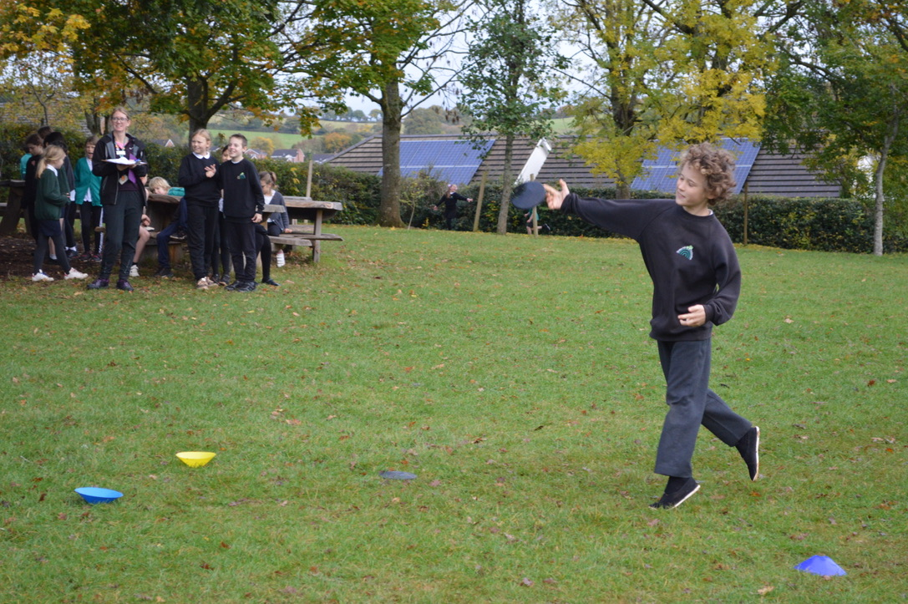
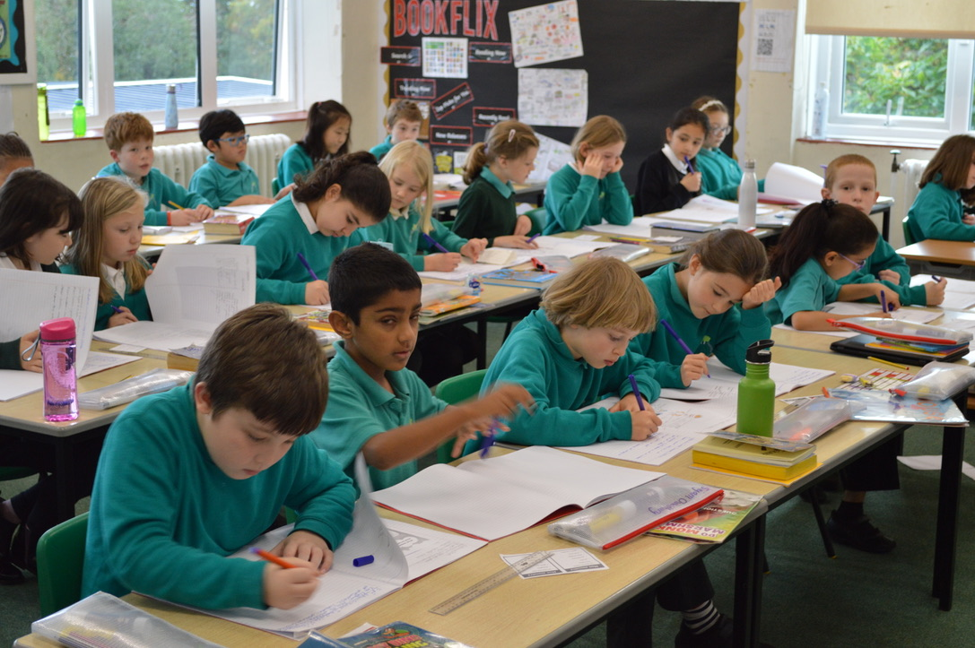
Because our ‘After School Club’ uses both playgrounds, the lower field and the play equipment, we need them to have access to all of these areas as soon as the school day ends. This means that unfortunately we have to ask that groups of children don’t play in these places before they go home. This will also help us to keep the children in their socially distanced bubbles.
Year 6 Secondary School Applications
The deadline for applying for a secondary school place is Saturday 31st October. We have a number of children who are waiting for 11+ results, and we have been told by Devon Admissions that even in these circumstances all applications still need to be submitted by the deadline. If you don’t apply by the 31st your child will be allocated a place at a school, but not necessarily the one you want them to go to.

It’s half term next week, so we’ll see you back at school on Monday 2nd November. Unlike some of the local secondary schools our half term holiday is for one week, not two!

Roy Souter

Class Superstars - October 23rd

3G - My class has been great this term because they have settled into the new school routines so well. They have approached their learning with enthusiasm and determination and I have been really impressed with the work they have produced. They have also demonstrated good cooperation and teamwork skills whilst making an erupting volcano. Thank you for the great start to the year.

3T - My class has been great this term because they have settled in so brilliantly to Junior school life. They have learned to be Ready, they are great at being Respectful, and they know how to keep themselves, and others Safe. I’m looking forward to seeing what they can achieve next half term. Have a well-deserved rest, 3T.

3M - My class has been great this term because they have settled so brilliantly into the Junior school. They have shown a great attitude to all the new challenges they have faced, and have approached every day with a smile. I’m having a great time, and particularly love our end of the day story time. They are definitely one of the best year 3 classes I’ve ever taught.

4CP - My class has been great this term because they have worked like Trojans learning about Ancient Greece. They have taken pride in presenting work neatly and have greatly improved their handwriting. Finally, as a class they have read a massive 2 million 163 thousand 864 words. Have a well-deserved break over half term.

4O - My class has been great this term because they have had a SUPER start to year 4! They have shown great enthusiasm and imagination in their story writing. They have a great attitude towards their learning and have shown great pride in their work. I am so proud of your efforts 4O! Well done.

4LP - My class has been great this term because they have shown enthusiasm and determination returning to school. They have enjoyed our Ancient Greek topic immensely and are now very knowledgeable about Greek myths, trade and democracy. All the children have worked tirelessly to present their work to the best of their ability and thoroughly deserve a half-term break. Well done 4LP!

5HM - Our class has been great this term because they have worked tirelessly to achieve their very best, taking great pride in all that they do. They are reading enthusiastically, trying so hard to complete Mathletics tasks to a really good standard and last, but definitely not least, they are kind, good humoured and never endingly helpful.

5J - My class has been great this term because they work so incredibly hard and with such good humour. Every week their work gets better and they take huge pride in making what they do beautiful. I have seen fabulous art, amazing arithmetic and epic stories. I am really proud. What a brilliant start.

5M - My class has been great this term because they have started Y5 with an excellent and mature attitude. They have been working incredibly hard in everything they do and I have seen huge improvements in all of their work, especially their maths! I am especially proud of them achieving the top class in the year group two weeks running on TTRS!

6M - My class has been great this term because they have settled into Year 6 brilliantly. They worked really hard in all the subjects and I have been very impressed with their effort. The best things so far have been the enthusiasm they have shown for their learning, their fantastic attitude towards their work and their sense of humour!. Well done 6M and enjoy your half term break.

6B - My class has been great this term because they have come back to school with lots of enthusiasm for learning and are always trying to achieve their best. They have worked really hard to improve their arithmetic skills and have learnt lots of facts about the Maya civilisation. Keep up the great work 6B!

6AE - Our class has been great this term because they have settled back into the school routine brilliantly, have impressed us with their enthusiasm for learning in all subjects and have already read an incredible 7,500,000 words! Well done 6AE!

