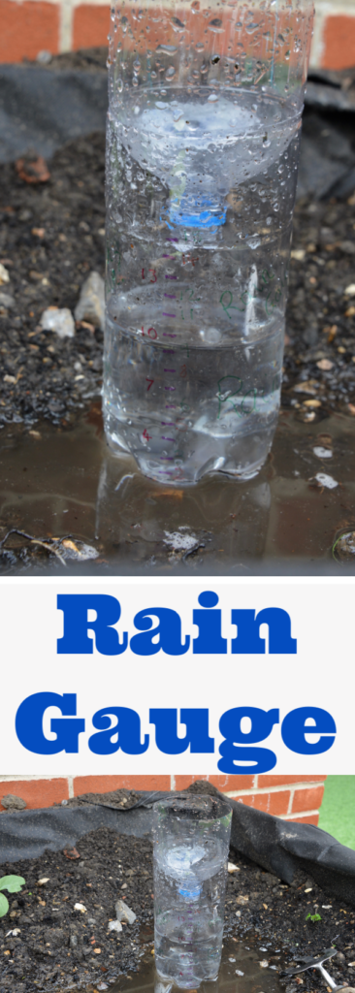
You will need
a clear plastic bottle
scissors
a marker pen
a ruler

Instructions
- Ask a grownup to cut the top part of the bottle off. Turn it upside down and push it into the top of the main part of the bottle like a funnel.
- Make marks on the side of the bottle at regular intervals. You could use the ruler and mark on the measurements in centimetres if you want to.
- Take your rain gauge outside and find a good place to place it. You will need and open spot and you might need to wedge it between some flower pots so it won’t blow away.
Keep an eye on that rainfall. Let’s hope there won’t be too much this week!

