Cope Cakes

At the moment things are really different and sometimes different is hard to cope with. That is really normal and lots of people are finding it hard at the moment. So lets find out what our coping skills are. Not everyone’s will be the same.

- Coping skills are the things that make you feel good and calm you down when we are feeling angry, worried, or sad.
- Some coping skills are healthy.
- Some coping skills are unhealthy.
We are going to look at what skills are healthy, and which are unhealthy.
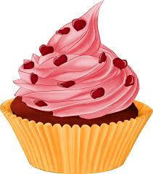
Then we will look at which coping skills work for you

Matching the Skills

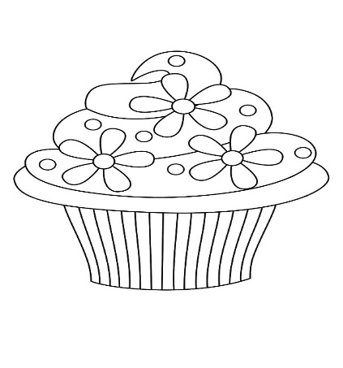
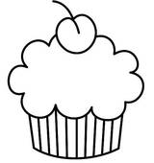
There are coping skills that are healthy and some that are not healthy. Match the healthy and unhealthy cope-cakes to the matching box with a line and then colour in the cakes.
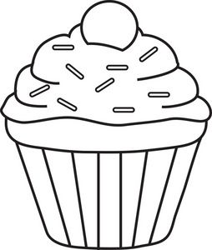
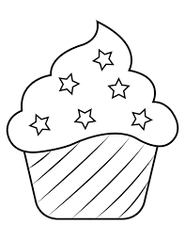

Yell at someone
Kick and hit out
Talk to someone about how you are feeling.
Do some exercise

Listen to some music
Take some deep breaths
Healthy Coping Skills
Unhealthy Coping Skills

Your Cope Cakes
A Cope Cake is a way of showing what your coping skills are. As we said before, everyone’s will be different.
Below are a range of coping skills, colour in the cake with coping skills that work for you, (there are some blank ones for you to add your own) then on the next page we will make a recipe for it!
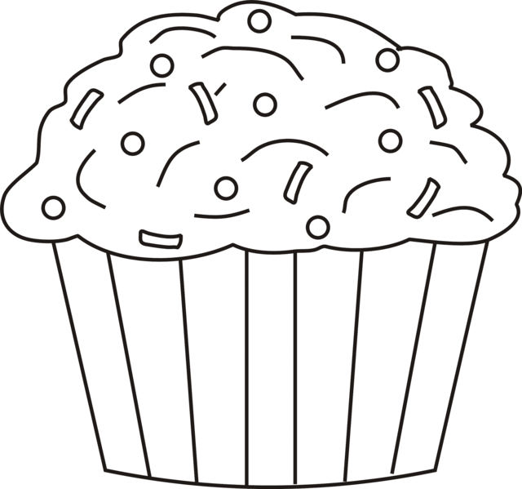
Listen to music

Talk about how you are feeling

Colour a picture
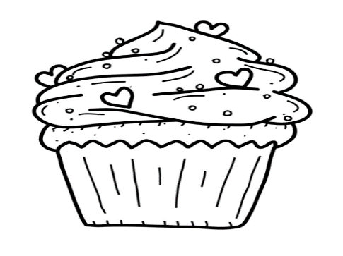
Take some deep breaths

Eat a healthy snack
Take a bath or shower

Exercise
Read a book
My Cope Cake Recipe

This is my example, you can have a go at your own recipe on the next page.

Ingredients:
Do 10 star jumps
Listen to my favourite music
Take a bath and relax

Directions:
When I am feeling worried, I will do 10-star jumps.
If I still feel worried, I will listen to my favourite music and maybe have a dance around the room.
Then I will have a nice warm bath and relax.

My Cope Cake Recipe
Whenever you get worried, sad or angry, use your Cope Cake Recipe to remind yourself of how you can cope with your difficult emotion. Colour in it and make it colourful!

Ingredients:

Directions:

